design document for

**IntelliRoast**

submitted to:

Dr. Yaroslav Koshka

ECE 4522: Senior Design II

Department of Electrical and Computer Engineering

413 Hardy Road, Box 9571

Mississippi State University

Mississippi State, Mississippi 39762

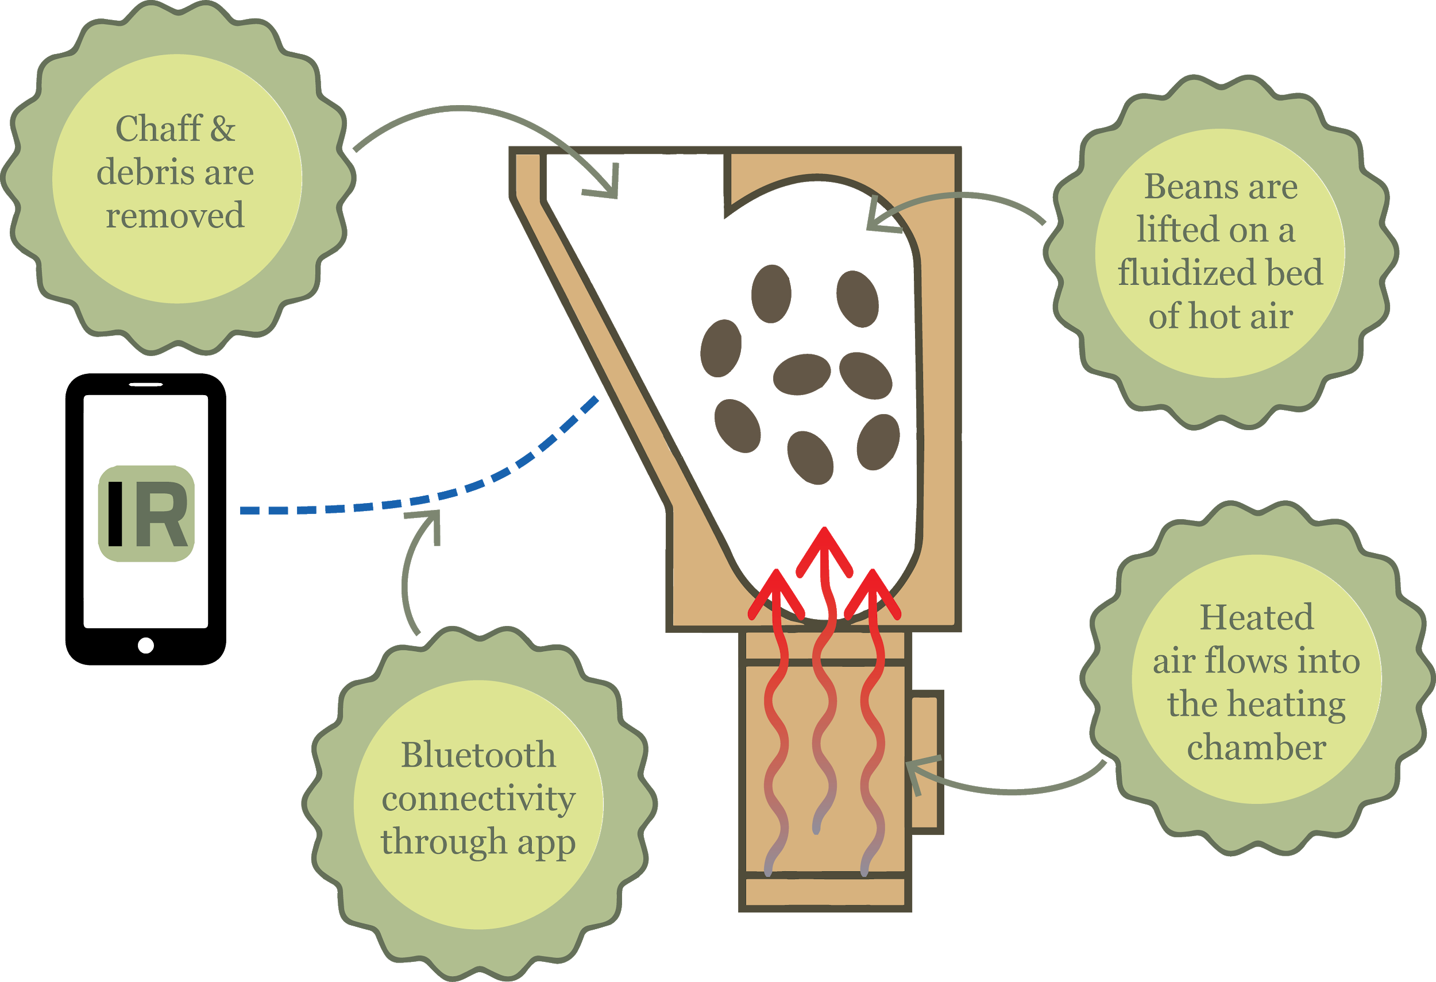

April 23, 2019  
Prepared by:

D. Bolland, C. Farrar, J. Jamora, N. Siano, and R. Siciliano

Faculty Advisor: Dr. Masoud Karimi-Ghartemani

Department of Electrical and Computer Engineering

Mississippi State University

413 Hardy Road, Box 9571

Mississippi State, Mississippi 39762

email: {dab438, wcf74, jj1753, nrs171, rs1515}@ece.msstate.edu

**LIST OF ABBREVIATIONS**

ADC - Analog-to-Digital Converter

ASTM - American Society for Testing and Materials

BLE - Bluetooth Low Energy

CFM - Cubic Feet per Minute

CMM - Cubic Meter per Minute

dBm - Decibel-Milliwatts

GATT - Generic Attribute

HAL - Hardware Abstraction Layer

IP - Ingress Protection

MCU - Microcontroller Unit

NEC - National Electrical Code

PCB - Printed Circuit Board

PID - Proportional-Integral-Derivative

PWM - Pulse Width Modulation

RSSI - Received Signal Strength Indicator

VAC - Volts in Alternating Current

VDC - Volts in Direct Current

**EXECUTIVE SUMMARY**

IntelliRoast is an in-home coffee roasting solution. By providing a companion smartphone app, a completely automated process, and the selection of custom roasts, IntelliRoast brings high-quality coffee to the masses. Coffee enthusiasts need access to freshly-roasted coffee beans at an inexpensive price.Large coffee companies provide cheap and convenient access at the cost of quality and freshness. Local roasters can provide a premium product at a price above what the average consumer may deem affordable. One way to access freshly roasted coffee is to roast beans at home.



**Figure 1: IntelliRoast System Overview**

IntelliRoast must roast 120 grams of beans without user intervention and allow the user to choose a roasting profile. A roast profile is a chart relating time to temperature of coffee beans, and is used to evenly roast coffee beans and extract the most flavor possible from the roast. A standard 12 cup pot of coffee uses about 120 grams of roasted beans, so IntelliRoast roasts enough coffee for one pot. To allow for use inside an average sized kitchen, IntelliRoast must have a usable wireless range of at least 3 meters. IntelliRoast must draw less than 1800 W of power in order to stay within standard US power outlet specifications. To sufficiently roast coffee beans, IntelliRoast’s internal roasting temperature must reach a temperature of 300 °C while keeping the external surface temperature under 60 °C to prevent injuries to the user.

IntelliRoast uses an electrically-heated roasting chamber and a smartphone application which chooses between different roast profiles. It uses a centrifugal fan to blow air over the heating element, thereby heating the air. Once the air is heated up to a sufficient temperature, it is blown into the bottom of the roasting chamber to roast and agitate the beans. Chaff, a flammable paper-like substance, flakes off of the roasting beans and is collected in a chaff collector. Once the beans are roasted to the desired roasting profile, they are blown into a bean collection bin for the user to retrieve. To keep costs down for the user, IntelliRoast uses high quality, inexpensive, and non-proprietary parts in its construction.

IntelliRoast offers affordable and fresh in-home coffee to entry-level lovers and enthusiasts. The microcontroller automates the roasting process and removes the steep learning curve many entry-level coffee enthusiasts face. Additionally, the paired smartphone application provides real-time feedback during the roast, such as the temperature of the roasting chamber and the progression through the roast profile. The ease of use coupled with the ability to monitor the roast makes IntelliRoast a powerful and useful tool for coffee lovers.

**TABLE OF CONTENTS**

**1.0 Problem** **6**

**1.1 Historical Introduction** **6**

**1.2 Market and Competitive Product Analysis** **6**

**1.3 Concise Problem Statement** **7**

**1.4 Implications of Success** **7**

**2.0 Design Requirements/Constraints** **9**

**2.1 Technical Design Constraints** **9**

**2.2 Practical Design Constraints** **10**

**2.3 Appropriate Engineering Standards** **12**

**3.0 Approach** **14**

**3.1 System Overview** **14**

**3.2 Mechanical** **14**

**3.3 Hardware** **22**

**3.4 Software** **31**

**4.0 Evaluation** **36**

**4.1 Test Certification - Power Draw** **36**

**4.2 Test Certification - Roasting Temperature** **37**

**4.3 Test Certification - Surface Temperature** **39**

**4.4 Test Certification - Fan Thrust** **40**

**4.5 Test Certification - Wireless Distance** **41**

**4.6 Test Certification - Full System Test** **43**

**5.0 Future Work** **46**

**6.0 Acknowledgements** **47**

**7.0 References** **48**

**8.0 Appendix: Product specification** **50**

# 1.0 Problem

## 1.1 Historical Introduction

Coffee as a commodity arrived in the European markets in the early 1600s [1, pp.1], with home coffee roasting as the standard during this time. With the arrival of the first electric commercial coffee roasters in the early 1900s [1, pp.647], home roasting declined and pre-packaged coffee became the norm. Small-scale coffee roasting began to return with the rise of dedicated coffeehouses in the 1960s, which sought out specialty coffee from around the world.

In the 1970s, Siemens introduced the Siemens Sirocco: the first mass-marketed home fluid bed roaster for the consumer. The Sirocco featured an infrared temperature sensor, high aeration to agitate the beans during the roasting process, and a timer complete with a built-in cooling cycle [2]. This product is widely regarded as the beginning of the home roasting resurgence due to its advanced feature set and its affordable price of $139 (~$320 in 2018).

The 1980s and 90s continued the trend with numerous coffee roaster design patents and releases on the market. This coincided with a rise in coffee varieties and growing popularity for specialty coffee. The increasing number of patents and releases began to revolutionize the coffee roasting market to its current status in the 21st century with a desire for user control, effectiveness, and ease of cleanup. This desire has created a new market today with a variety of intelligent home-roasting options and room for new innovations. IntelliRoast fits into this market by offering a smart home-roasting option with easy cleanup and overall

## 1.2 Market and Competitive Product Analysis

The coffee roasting community judges the quality and appeal of roasting machines by the capacity of beans being roasted, amount of user-controlled variability in terms of selecting different roast profiles, effectiveness in both its heating and cooling cycles, ability to reduce smoke during roasting, and ease of cleanup [3]. Bean capacity ranges from 100 grams in small machines to 450 grams for ultra-large capacity roasters within the consumer spectrum. Customizability of the roasting process varies from a simple power switch to a fully editable temperature control interface. Machines in the current coffee roasting market will usually excel in one technical area, such as high capacity or efficient smoke reduction, but lack in others, like user-controlled variability. A typical consumer coffee roasting machine costs anywhere between $150 and $1700 depending on the feature set [3].

The most direct competitor for IntelliRoast is the Ikawa Smart Home Coffee Roasting System. The Ikawa is constructed from ultra-premium materials such as an extruded aluminum case and cork insulating material. This particular roaster features app connectivity and Dyson vacuum technology for its convection-style roasting. These premium materials and technologies exceed $1600 [4] - a price only the top percentage of coffee enthusiasts would entertain.

IntelliRoast brings a premium coffee roasting experience and quality without the premium cost. By utilizing the high cubic feet per minute (CFM) and high static pressure of a centrifugal style fan, IntelliRoast is able to push 54.7 CFM into the roasting chamber. This high flow solution is most effective for the rapid heating and cooling necessary to roast coffee beans and provides enough static pressure to agitate the beans for even roasting. By using high quality yet inexpensive materials, IntelliRoast can keep costs down near an entry-level roasting machine and offer all the same features of a high-end roasting machine.

## 1.3 Concise Problem Statement

Coffee roasting is an intricate process the average consumer cannot consistently perform alone. Roasting coffee at home requires the user to already know the science behind coffee roasting. Different transition points are mostly based on observations and are normally determined by prior experience. Even if a user performs a perfect roast, the variability in these transition points makes repeating a coffee roast a difficult process.

Most commercial coffee sellers roast coffee beans in large batches to appeal to the average consumer. By the time their products reach market shelves, their coffee is normally past their prime and does not appeal to coffee enthusiasts. This makes home roasting techniques a necessity. A consumer could buy the green coffee beans online, but the tools required to consistently roast those coffee beans are expensive and typically only found at a coffee roasting company. Those who can afford to buy a coffee roasting machine enjoy a great roasting experience at home but at a very high price, upwards of $1600 [4].

Many coffee enthusiasts roast coffee at home using homemade tools, such as a repurposed popcorn popper or a cast iron skillet on a stovetop [5]. Using these tools require intricate knowledge into coffee roasting science. Neither popcorn poppers or cast iron skillets do not have any indications on when to transition to different stages of the coffee roasting process. Both of these tools require a certain amount of skill to effectively use for coffee roasting. Additionally, these roasting methods require the user to constantly supervise the coffee roasting process.

IntelliRoast offers an in-home solution to average coffee roasting needs by providing a customizable roasting experience at an affordable price. IntelliRoast automatically roasts the coffee beans without manual intervention while using the same roasting technology hobbyists are accustomed to using. Additionally, a smartphone app can be used to customize the roasting process to create and save user-defined roast profiles. Using this technology, the average user can easily perform the complex roasting process at a fraction of the cost of the current technology available on the market.

## 1.4 Implications of Success

The overall goal for IntelliRoast is to roast coffee beans to extract the maximum flavor possible. This product will offer a more efficient and automated method for a traditionally manual process. Additionally, IntelliRoast could reduce the variability in different coffee roasts to offer a consistent, high-quality product. With its low cost and user-friendly interface, IntelliRoast could become a major market competitor based on current coffee roasting trends. Smaller coffee bars featuring locally roasted coffee could start offering their own roasted beans in-shop. The possibility of wider commercial success could affect larger coffee companies as users start roasting their own coffee beans and rely less on commercially roasted coffee.

IntelliRoast’s marketability will lead to its success. The ease of use will prove a hands-off alternative to current imprecise methods. IntelliRoast’s automation would reduce the time spent constantly supervising coffee roasts and allow the user to focus on other tasks. Additionally, IntelliRoast will create an easier entry point into high-end coffee by way of its lower price. The average consumer would have the ability to easily enjoy their own roasted beans. It will directly compete with products in the current coffee roasting market and sustain a viable business product. In the future, IntelliRoast could become a commonplace household appliance.

# 

# 2.0 Design Requirements/Constraints

IntelliRoast must successfully roast 120 grams of coffee beans based on a predetermined roasting profile selected by the user via a smartphone application. To accomplish this, it must heat the bean roasting chamber to 300 °C while retaining a surface temperature of less than 60 °C. IntelliRoast must agitate the beans during the roasting process and eject them from the roasting chamber at the conclusion of the roast. These combined aspects ensure IntelliRoast roasts coffee beans both quickly and safely. Additionally, IntelliRoast provides a cost-effective alternative to existing products with similar feature sets.

The sections of the design constraints below discuss IntelliRoast’s technical and practical constraints, as well as engineering standards it must follow. Technical constraints refer to the essential needs of the design, while practical constraints refer to the operational requirements and regulations during usage.

## **2.1** **Technical Design Constraints**

Table 2.1 contains the five technical design constraints that must be adhered to upon completion of this product.

**Table 2.1 Technical Design Constraints**

|  |  |
| --- | --- |
| **Name** | **Description** |
| Power Draw | IntelliRoast must draw under 15 A at 120 V to comply with NEC standards for kitchen circuit current limits [6]. |
| Roasting Temperature | The heating element must heat the roasting chamber to a minimum of 300 °C. |
| Surface Temperature | IntelliRoast must comply with ASTM C1055 standards to protect the user from irreversible injuries [7]. The device’s exterior enclosure must not exceed 60 °C. |
| Bean Agitation | IntelliRoast’s fan must lift a maximum of 120 g of beans to agitate during roasting and eject from the chamber after the roast is finished. |
| Wireless Distance | IntelliRoast must connect to the user’s smartphone from a maximum distance of 3 meters. |

**2.1.1 Power Draw**

IntelliRoast must not exceed 15 amps, the average current draw for kitchen appliances. The National Electrical Code (NEC) specifies that the average kitchen should have, at a minimum, two circuits rated for 20 amps at 120 VAC [6]. The general practice for current rating is that the continuous draw should not exceed 80 percent of the rated capacity. At 20 amps, the continuous current draw rating equals 16 amps. IntelliRoast’s constraint of 15 amps adheres to NEC specifications and still operates within homes which do not meet this specification.

**2.1.2 Roasting Temperature**

IntelliRoast must sustain an ambient temperature of 300 °C within the roasting chamber. Depending on the roast level, the process of roasting coffee requires the beans to reach an internal temperature of 205 °C - 250 °C [8]. This target temperature will roast the beans within the target timeframe of 10-12 minutes.

**2.1.2 Surface Temperature**

IntelliRoast’s exterior enclosure must not exceed a surface temperature of 60 °C. ASTM C1055 standards specify the surface temperature of 70 °C as the upper limit for safe operation, as temperatures exceeding this maximum presents a burn risk for the user. IntelliRoast’s constraint of 60 °C adheres to ASTM standards and further reduces first-degree burn risk.

**2.1.4 Bean Agitation**

IntelliRoast’s fan must lift and agitate approximately 120 grams of beans during roasting and eject them from the chamber after the roasting process is finished. 120 grams of coffee is enough for twelve 6-ounce cups, or 1 pot, of coffee [9]. If the beans are not mixed and agitated during the roasting process, they will roast unevenly. The beans at the bottom of the chamber could char while others may not roast. In order to simplify the mechanical design, the beans will share a single entrance and exit from the chamber.

**2.1.5 Wireless Distance**

IntelliRoast must communicate wirelessly between the device and the user’s smartphone at a distance of 3 meters or less. In 2009, the National Kitchen and Bathroom Association defined the average kitchen area as approximately a 10 by 10-foot root with an area of 100 square feet [10]. Our 3-meter radial requirement allows continuous connectivity throughout the entire average kitchen space, ensuring no disconnection or data loss while the user tends to other tasks within the kitchen.

## 2.2 Practical Design Constraints

The product must also adhere to the five practical constraints listed in Table 2.2.

**Table 2.2 Practical Design Constraints**

|  |  |  |
| --- | --- | --- |
| **Type** | **Name** | **Description** |
| Environmental | Water Resistance | IntelliRoast must comply with IP53 standards [11]. |
| Economic | Cost | In order to compete on the open market, IntelliRoast should cost roughly less than $500 due to part costs and retail markup. |
| Sustainability | Hands-Free Usage | IntelliRoast must roast and eject beans without the intervention of the user after the selection of roast and insertion of beans. |
| Social | App-Enabled | IntelliRoast must interact with a companion smartphone app to allow for remote usage. |
| Safety | Chaff Collection | IntelliRoast must have the ability to collect a minimum of 98% of the total chaff to avoid potential fire hazards. |

**2.2.1 Environmental**

IP standards call for “protection of persons against access to hazardous parts, and protection of equipment against ingress of solid foreign objects” and “protection of equipment against harmful ingress of water” [11]. IntelliRoast must comply with IP53 ingress standards. The main operating environment will contain hazards such as foreign objects and liquids. IntelliRoast’s IP53 rating will protect the equipment from the entry of dust and water sprays approaching from an angle of 60 degrees. These constraints are acceptable for kitchen appliances because these standards call for protection against foreign objects like food and utensils normally in an average kitchen. Since liquids are not actively present on a kitchen counter, IntelliRoast only needs to protect from accidental contact with water. The IP53 standards meet both of these requirements.

**2.2.2 Economic**

Since IntelliRoast is competing against home coffee roasters costing upwards of $1600, it must cost less than $500 for consumers [12]. This significant cost difference makes IntelliRoast a viable competitor in the current coffee roasting market. Even though the price is set primarily through the electronics and heating element, the production cost of IntelliRoast is lower than its competitors. The custom-printed components and off-shelf elements make IntelliRoast significantly cheaper than its competitors.

**2.2.3 Sustainability**

IntelliRoast’s roasting process must be fully automated. The preparation of the roast is designed to be a customizable user experience, and after initiating the roast, the process is entirely hands-off. Internally, IntelliRoast must heat up its heating coil, monitor bean temperature, and adjust the airflow and chamber temperature based on the roasting profile without user influence or any outside assistance. Currently, the coffee roasting process is entirely human-operated and adds inconsistency in quality between coffee roasts. The automation of these key steps will ensure the exact roast profile is easily and quickly repeatable.

**2.2.4 Social**

IntelliRoast’s companion phone app must allow the user to select and customize their roast profiles, start the roasting process, and view other important information about the roast. The app must have an easy-to-use interface requiring no prior training.

**2.2.5 Safety**

IntelliRoast must collect the chaff in a container for disposal. Chaff, a paper-like substance, flakes off coffee beans during the roasting process. If not properly collected and disposed of, chaff can create a fire hazard. IntelliRoast will keep all chaff away from heating elements in order to eliminate a risk of combustion. Even with this potential fire hazard, IntelliRoast will not have any openings for the chaff to go near the heating element.

## 2.3 Appropriate Engineering Standards

Table 2.3 contains engineering standards used by IntelliRoast.

**Table 2.3. Appropriate Engineering Standards**

|  |  |  |
| --- | --- | --- |
| **Specific Standard** | **Standard Document** | **Specification/ application** |
| ASTM C1055 | Standard Guide for Heated System Surface Conditions that Produce Contact Burn Injuries | The surface temperature must be below 70°C. |
| IEC-60529 | Degrees of protection provided by enclosures (IP Code) | The device must abide by IP ratings to protect against the intrusion of solid objects and water. |

**2.3.1 ASTM C1055**

IntelliRoast must comply with ASTM standards to determine acceptable operating conditions for heated systems. ASTM C1055 recommends the maximum injury level is causing first-degree burns on the average subject [6], and this is caused by temporary exposure to a surface temperature of 70°C. The maximum surface temperature of 60°C ensures IntelliRoast abides by ASTM C1055 standards and further reduces first-degree burn risk.

**2.3.2 IEC-60529**

IEC-60529 standards define the device’s protection against external objects and liquids as the IP Code [11]. IntelliRoast’s adherence to IP53 standards will allow for protection against dust and water sprays approaching from an angle of 60 degrees.

# 

# 3.0 Approach

IntelliRoast provides a customizable coffee roasting experience at an affordable price. By using a companion smartphone application, the user can create and save user-defined roast profiles. IntelliRoast uses a heating element and a centrifugal fan operated by a microcontroller to agitate and roast the coffee beans to the chosen profile. Once the beans are roasted, they are blown out of the heating chamber for easy removal into a holding container.

## 3.1 System Overview

IntelliRoast includes several systems and controls that work together to create an automatic coffee roasting machine. The hardware includes a fan, a heating element, temperature probes, a roasting chamber, a chaff separation unit, a chaff collection system, a bean deposit system, and a microcontroller. The microcontroller will contain logic to adjust fan speeds, heating element temperatures, and the bean deposit system.

The user begins by placing the green coffee beans in the roasting chamber and pressing the start button. Once the roast has been started, the microcontroller will adjust the temperature and speed of the air to roast the beans according to a default roast profile. Users can also use a smartphone application to select from multiple roast profiles, view roast progress and details, and start or stop the roast. After the beans are roasted, the microcontroller will increase the fan speed to blow the beans from the roasting chamber into a holding container. After the roasting process finishes, the user will have enough freshly roasted coffee beans to brew half a pound of roasted coffee beans.

## 3.2 Mechanical

The mechanical components for IntelliRoast contains all of the physical components related to the construction of the IntelliRoast prototype, which is pictured in Figure 3.2a below.

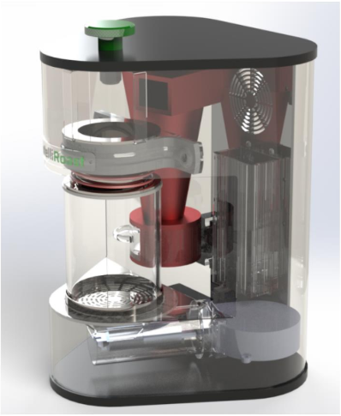

**Figure 3.2a: IntelliRoast Prototype Mechanical Design**

The second rendition of IntelliRoast’s prototype includes piping connecting the fan to the roasting chamber. Custom-printed 3D parts connect the roasting chamber to the locking mechanism and the cyclone separator. The cyclone separator is connected to a plastic enclosure at the bottom, with a drawer to house the chaff for collection. The following sections outline the motivations behind the prototype’s heating system choices and related parts, including the roasting chamber, chaff filtering system, and heat insulation.

**3.2.1 Heating System Options**

The type of heating system affects IntelliRoast’s performance. Coffee beans are roasted by one of two heating systems: fluid bed heating and drum heating. These two methods of heating vary in terms of batch sizes and effort introduced into the coffee roast. Due to its in-home nature, IntelliRoast uses fluid bed heating for roasting the green coffee beans. Table 3.2a shows the comparison of heating options considered.

**Table 3.2a - Comparison of Heating System Options**

|  |  |  |
| --- | --- | --- |
| **System** | **Description** | **Properties** |
| Fluid Bed Heating | Uses heated air to agitate beans and roast beans evenly | Uses 100% convection |
| Drum Heating | Uses a metal drum to hold beans and overheated element while stirring beans | Uses 75% convection  Uses 25% conduction |

Best Option/Meets Requirements Does Not Meet Requirements

Drum roasting rotates a large metal drum containing unroasted coffee beans heated from underneath by propane, natural gas, or electrical sources. This style of roasting is most effective on a large scale, where pounds of beans are roasted at a time, and is the most common choice for large companies in the industry. Since drum roasting directly heats the beans in a metal drum, the beans are less likely to have a homogeneous roast resulting in unevenly roasted beans [13]. Drum roasting also requires more mechanical and chemical parts to operate, such as motors to rotate the drum and a power supply to ignite for heat. For small-scale applications, like in-home roasting, drum roasting is not the preferred method due to requiring constant supervision.

Fluid bed roasting blows heated air into the roasting chamber, agitating and roasting the beans. This method roasts a smaller amount of beans and takes about half as much time as drum roasting [13]. Additionally, fluid bed roasting requires fewer mechanical parts and provides for easier clean-up. No gas or flame is used to roast the beans; instead, a heating element heats the air needed for the roast. Since fluid bed roasting is faster, cleaner, and hands-free, it is the preferred method for in-home roasting. A diagram of IntelliRoast’s fluid-bed roasting system is outlined later in Section 3.3.1.1.

**3.2.2 Roasting Chamber Assembly**

The following section discusses the mechanical and material selection related to the roasting chamber and the mechanisms allowing for the chamber to be removable.

**3.2.2.1 Roasting Chamber**

A roasting chamber will be used to roast the beans. To prevent burning beans and under-roasting others, air needs to agitate the beans enough to move them around throughout the entire process. IntelliRoast uses a pre-constructed chamber with small concentric circular slits in the bottom of the chamber to allow air to circulate while rotating and mixing the beans. Figure 3.2b shows the roasting chamber with unroasted coffee beans.

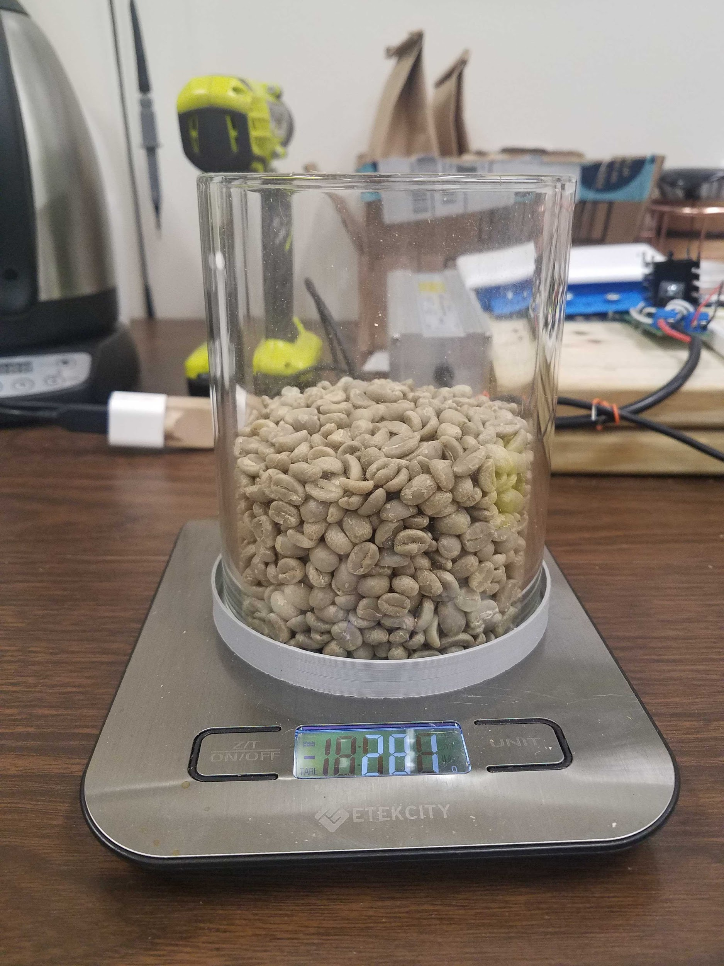

**Figure 3.2b: IntelliRoast Roasting Chamber with 281 grams of Beans**

The original chamber was designed from sheet metal with caulking to seal gaps. This allowed for IntelliRoast to hold about 120 grams of unroasted coffee beans. However, as later discussed in Section 3.2.4.1, the material choices introduced major heat loss and burn risks. The current chamber is constructed from glass to visually confirm agitation for the user’s benefit. Although the glass chamber would be hot to touch during the roasting process, its low thermal conductivity and gradual heating process combined with the cooling cycles negate this issue. The dimensions of the chamber allow for a half pound (about 230 grams) of roasted beans, or about 285 grams of unroasted green coffee beans. This translates to a 12.7 cm height requirement and a 10.16 cm diameter requirement for the roasting chamber.

**3.2.2.2 Chamber Removal Mechanism**

A lever and spring system is used to unseal the chamber from the prototype to allow for easy loading and removal of beans. While the prototype’s locking mechanism is made of metal, the model shown in Figure 3.2c is made from 3D-printed components to highlight the assembly.

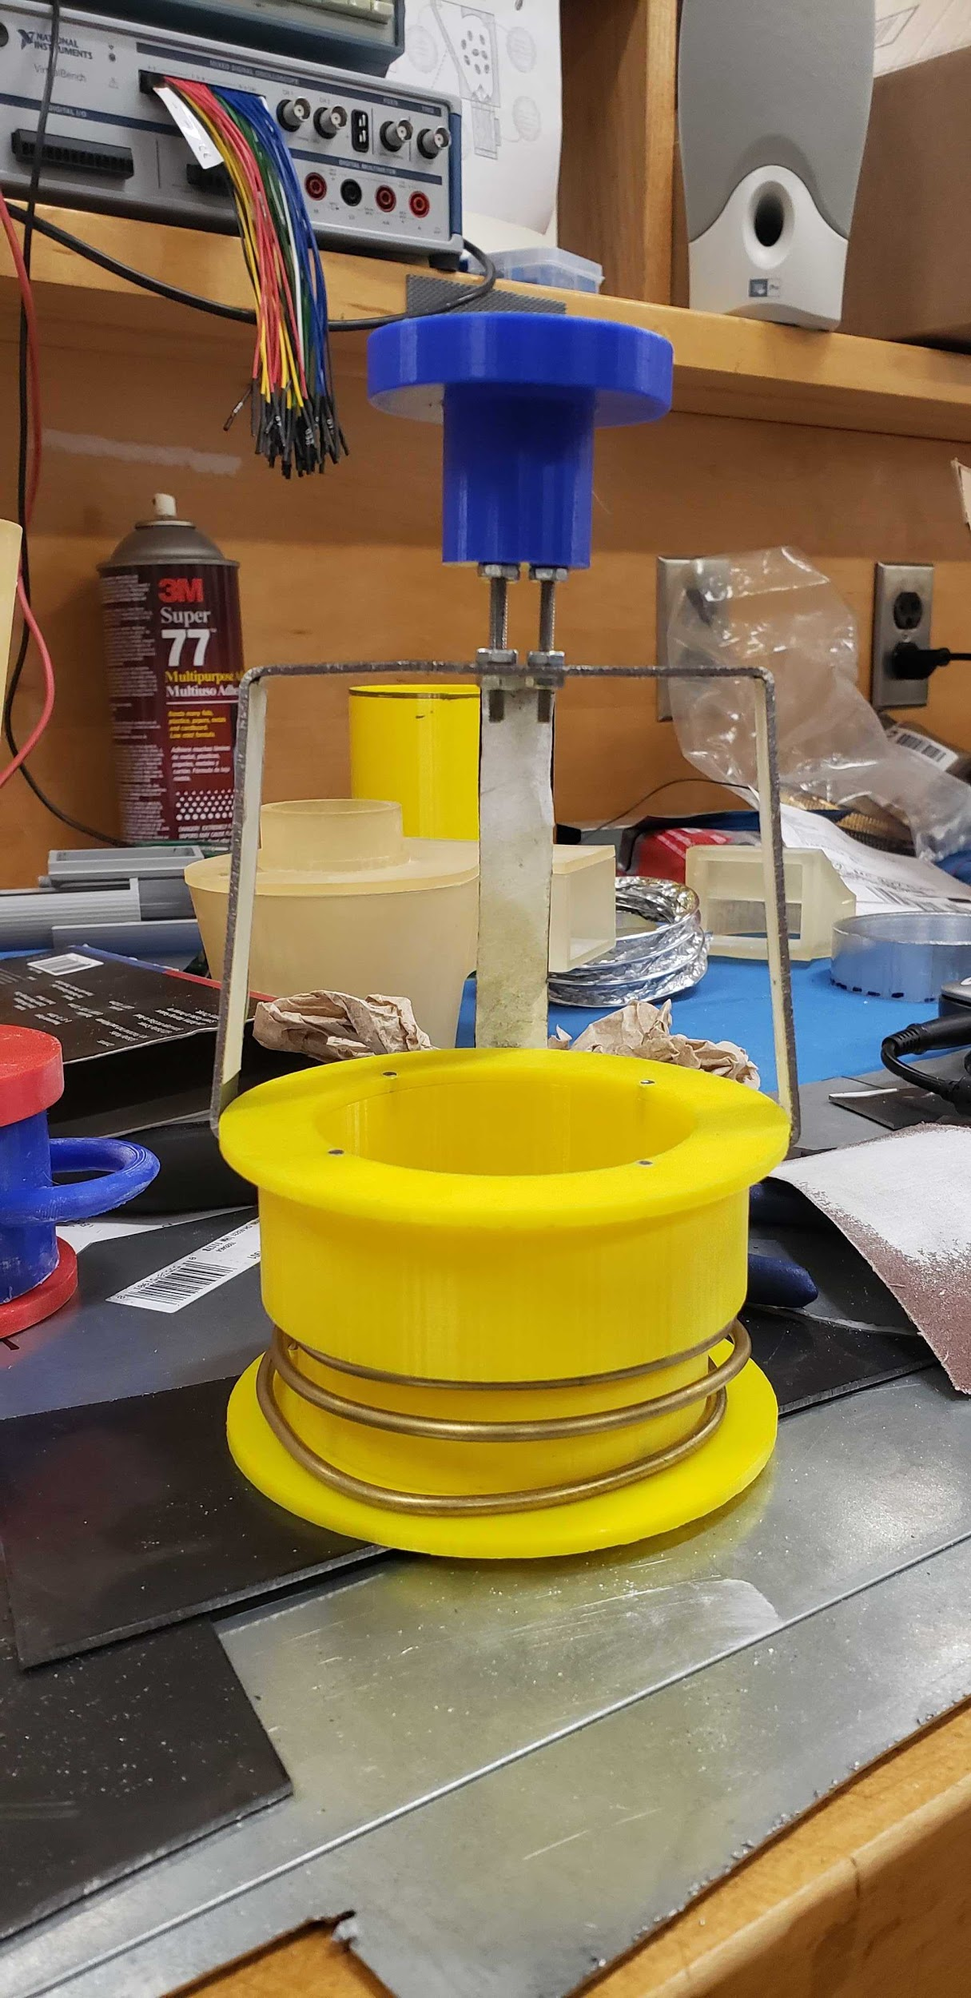

**Figure 3.2c**: **Chamber Removal Assembly Model**

A chamber removal assembly is necessary due to IntelliRoast’s desire to have the ability of removing the beans after they are finished roasting. IntelliRoast’s chamber removal assembly consists of a spring system holding the metal locking rings in place and a claw holding the rings. The claw is attached to the top of the locking rings and fits over the top of the glass roasting chamber. The chamber removal assembly will be located near the top of the prototype and can be used via the knob at the top of the apparatus. Pulling the knob upwards results in the apparatus sliding up, freeing the chamber for easy bean removal. When in place, the assembly traps all air inside the roasting chamber and pressurizes the chamber.

**3.2.3 Filtering System**

Chaff is a paper-like by-product of the coffee bean roasting process, and it can create a fire hazard if not properly removed. Additionally, coffee beans could unevenly roast if the chaff remains uncollected. A separator is necessary to separate the chaff from the rest of the beans inside the heating chamber. A cyclone dust separator was selected as IntelliRoast’s filtering system because of its ability to quickly and efficiently filter large debris from the air stream.

Cyclone separators are a mechanical separation technology introducing gas with solid particles at the top of the cyclone structure. This air stream enters through a rectangular entry point at the top of the funnel and travels along the interior wall. The velocity of the air increases as the diameter decreases. At a certain point, the particles do not have enough inertia to travel along the wall, falling to the bottom due to gravity. The air continues to travel along the wall, which pushes the particles down and eventually travels up to the center of the cyclone and out the top hole.

An added benefit of the cyclone separator is the low maintenance required; cyclone separators save money because they do not require replacement filters or dust bags [14]. Table 3.2h below outlines the options for different cyclone systems.

**Table 3.2h - Cyclone Separator Comparisons**

|  |  |  |  |  |
| --- | --- | --- | --- | --- |
| **Cyclone Separators** | **Efficiency** | **Weight** | **Dimensions** | **Price/Costs** |
| Cyclone Powder Dust Collector | 99% | 21.16 oz (600 g) | 11.81” x 7.09” x 6.30”  (30 cm x 18 cm x 16 cm) | $23.99 |
| Custom 3D Printed Cyclone Separator | High | Adjustable | Adjustable | Filament for 3D Printing |

Best Option/Meets Requirements Does Not Meet Requirements

The cyclone separator that comes closest to meeting IntelliRoast’s chaff separation requirement is the SN50 High-Efficiency Cyclone Powder Dust Collector. Its main use is to attach to shop vacuums, which are noticeably larger than consumer kitchen appliances. The SN50 can separate 99% of dust and debris without clogging the separator or reducing the airflow. Although its features are desirable, IntelliRoast plans to use a smaller version of a similar separator. The dimensions on the SN50 separator are 30 x 18 x 16 cm, which are too large to fit inside a consumer-level coffee roaster.

Taking the fundamental design for cyclone separation from the SN50, a 17.75 cm tall 3D-printed solution was fabricated. A conical funnel was created with a high-temperature resin, mimicking the SN50’s design, allowing chaff to fall to the bottom of the cyclone separator by gravity. A rectangular hole is created at the top to increase the efficiency of chaff moving from the attached roasting chamber into the cyclone separator. A circular hole at the top allows air to escape the cyclone separator, letting the chaff fall into the plastic drawer at the bottom. The plastic drawer is constructed from plastic to ensure easy removal and cleaning. The chaff collector used in the prototype is shown in Figure 3.2d.

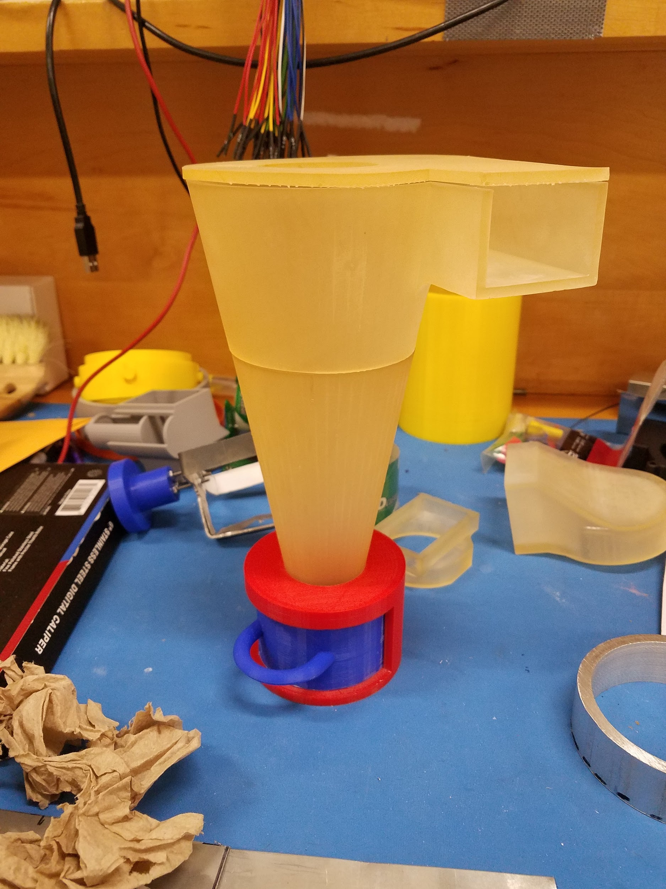

**Figure 3.2d - Cyclone Separator Chaff Collector**

**3.2.4 Heat Insulation**

The sections below discuss the hardware selections for the heat transfer and insulation requirements to keep the external enclosure surface temperature within acceptable levels.

**3.2.4.1 Piping**

IntelliRoast uses black iron piping to transport air from the centrifugal fan through the heating element to the coffee beans. Because the pipes have superheated air pumped through them, the material used must withstand high temperatures without oxidation, breakdown, or melting. Additionally, high-pressure air flows through the system; therefore, the piping must remain airtight under these conditions.

Black iron, galvanized steel, copper piping, and stainless steel were investigated for this purpose. Copper piping is used primarily for heating elements as the metal absorbs heat exceptionally well. This option will cause the most heat loss between the heating element and the beans. In addition, the traditional method of connecting copper pipe is through clamping the piping at a connection, meaning any necessary changes beyond initial installation would be difficult.

Alternatively, black iron, galvanized steel, and stainless steel prevent heat absorption, making them better for transferring hot air with the least amount of heat loss. Black iron, galvanized steel, and stainless steel both have threaded ends to their piping, making connections and adjustment much easier. As shown in Figure 3.2bb, galvanized metals have a significant drawback of peeling the toxic zinc coating at high temperatures, which creates a health hazard [15]. This health hazard makes galvanized metals non-food safe, especially considering the high temperatures IntelliRoast operates. Both black iron and stainless steel are food-safe, but black iron piping introduces heat loss and unsafe operating conditions. The area near the black iron piping becomes hot to the touch, and for these reasons, stainless steel is the best option for the piping of the heat transfer area.

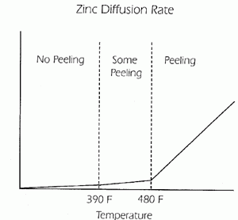

**Figure 3.2bb - Zinc Diffusion Rate of Coat Peeling [15]**

**Table 3.2d - Piping Material Comparison**

|  |  |  |  |  |
| --- | --- | --- | --- | --- |
| **Material** | **Price per 3-inch Unit (USD)** | **Heat Absorption** | **Style of connection** | **Food Safe** |
| Black Iron | $1.55 | Low | Pipe Threading | Yes |
| Copper | N/A (Cut to size) | High | Friction Crimping | Yes |
| Galvanized Steel | $2.50 | Low | Pipe Threading | No |
| Stainless Steel | $2.80 | Low | Pipe Threading | Yes |

Best Option/Meets Requirements Does Not Meet Requirements

**3.2.4.2 Insulation**

Two major types of fire protection are available on the current market: fire barriers and insulation. Fire barriers restrict the spread of fire by expanding themselves to encapsulate the fire and prevent it from spreading to other areas. Fire barriers are used in large-scale applications like housing because of the amount of space available to decrease the environment temperature and trap fires. Meanwhile, insulation reduces heat transfer between objects of varying temperatures by reducing heat flow through an intermediate material between the two objects. Smaller-scale applications like kitchen appliances use insulation because of the lack of space available to trap fire. Dissipating high temperature is a necessity to prevent other internal components from catching on fire. For this prototype, insulation wraps around the stainless steel discussed in Section 3.2.4.1 to reduce the heat loss past the heating element.

Effective insulation consists of materials with a high resistance to heat flow, which is a thermodynamic value called the R-value. An R-value is a normalized value which dictates how effective a material can resist heat flow through the object itself. This value depends on the material’s thermal conductivity – how well a material can attract and trap heat – and the thickness of the material. Equation (1) represents the R-value of a material [16]

$R = l / λ$ (1)

where *l* is the thickness of the material and *λ* is the thermal conductivity of the material.

A material with either a lower thermal conductivity or a larger thickness will have a higher R-value. Good insulators have a higher resistance to heat flow and therefore a higher R-value. Therefore, IntelliRoast’s insulation requires a high R-value to provide maximum insulation effectiveness. Below, Table 3.2e shows a comparison between the insulation materials considered for the outside of the heating chamber.

**Table 3.2e - Insulation Material Comparison**

|  |  |  |  |  |
| --- | --- | --- | --- | --- |
| **Description** | **Price (USD)** | **Primary Material** | **Thickness (mm)** | **R-Value** |
| **Requirement** | < 20 | Fiberglass | 15.0 | 2 |
| ROXUL Mineral Wool/Foil Backing High-Temperature Insulation [17] | 15.65 | Fiberglass | 25.4 | 4 |
| STI Fire Barrier Wrap Strip [18] | 56.09 | Aluminum | 3.18 | 0.005 |
| 3M Fire Barrier Packing Material [19] | 21.11 | Fiberglass | 12.7 | 2 |
| Fiberglass High Temp Tape [20] | 13.10 | Fiberglass | 1.59 | 0.25 |

Best Option/Meets Requirements Does Not Meet Requirements

Both fire barrier strips and insulation were considered for this purpose. Fire barrier wrap strips, such as the STI product, are made of metals with a high thermal conductivity since these are meant to catch and restrict fire flow. Additionally, the lack of documentation and proper use cases for this product made the STI Fire Barrier Wrap Strip undesirable to use [17]. This and their small thickness made fire barrier strips an ineffective solution for IntelliRoast’s insulation, as seen by their small R values. Alternatively, the other products are fiberglass-based and have substantially higher R values compared to the STI Fire Barrier Wrap Strip. Both the 3M Fire Barrier Packing Material and the Fiberglass High-Temperature Tape are different types of loose-fill insulation. While easier to implement in hard-to-reach places, this is not ideal for IntelliRoast because of the commercial use of kitchen appliances. These appliances are prone to movement, and loose-fill insulation has a higher chance of becoming dislodged inside the device.

Ideally, IntelliRoast does not plan on inserting insulation inside the prototype near components handling coffee beans. Insulation material selection is included as a last-resort fail-safe measure in case a hot air leak is present. This is because fiberglass is composed of chemical properties unsafe for human consumption if it contacts food. However, this risk is negated because of the material selected for the overall system, including steel piping, a glass roasting chamber, 3D parts constructed from high temperature resin, and general isolation between the enclosure of the product and heated components.

The ROXUL Mineral Wool/Foil Backing High-Temperature Insulation operates with a temperature range between -17.8 °C to 648.9 °C, which is sufficient for insulating the area around the heating element since the heating element is rated to 371 °C [17]. This material has a length of 1.21 meters and a thickness of 25.4 millimeters, which can be cut or stacked to fit inside the device itself. Furthermore, this material is not a loose-fill material and will not move around while inside IntelliRoast. ROXUL’s mineral wool was selected as the insulation of choice for IntelliRoast because of its high R-value for its price.

## 3.3 Hardware

This section details the internal electrical components comprising IntelliRoast. These components must be selected in terms of size, budget, and power, and they must conform to the constraints of an average home kitchen appliance. Component requirements were researched based on the current in-home coffee roasting process. Since IntelliRoast will compete with other products on the market, components were selected to outperform other similar products.

**3.3.1 Heating System**

The heating solution for IntelliRoast is separated into two categories: the heating element and electronics to control the heating element.

**3.3.1.1 Heating Element**

IntelliRoast uses the Master Appliance REPL Heating Element HG501A [21] to heat the green beans to be roasted. Table 3.3a shows a comparison of the heating elements considered for the system.

**Table 3.3a - Heating Element Characteristics**

|  |  |  |  |  |
| --- | --- | --- | --- | --- |
| **Element** | **Price per Unit (USD)** | **Description** | **Properties**  **Required: 300°C** | **Power Rating** |
| REPL Heating Element for HG501A [21] | 28.20 | Heating element | 500 °F ~ 700 °F (260 °C ~ 371 °C) | 1680 W |
| Custom Resistive Wire | 21.88/32 ft | Nickel chromium wire only | ~1850 °F  (~1010 °C) | 1000-1100 W |
| PTC Heating Element Heater | 23.41 | Heating element | ~200 ± 10 °C | 1000 W |

Best Option/Meets Requirements Does Not Meet Requirements

A custom resistive wire solution is an alternative option to the heating element. The resistive wire is made from the same nickel chromium metal as the heating element and costs less per unit respectively. However, the resistive wire solution would require additional insulating material and time spent assembling a heating element. Furthermore, assembling a custom resistive wire solution would introduce uneven heat distribution since the coiling in the wire would be unevenly assembled. The wire itself has a higher temperature rating, but a new temperature rating would need to be calculated after assembly of a heating element.

IntelliRoast will use the REPL Heating Element for the HG501A, a pre-coiled heating element, to roast the green coffee beans. This heating element requires no assembly, unlike the resistive wire solution. The heating element will heat the air to a maximum of 300 °C consistently throughout the roasting process since the temperature is within the element’s heating limits. Air will be blown over the heating element using the centrifugal fan. The now-heated 300 °C air will agitate the beans and evenly roast them to the target temperature of 205 °C - 250 °C. Figure 3.3a shows the schematic for this process.

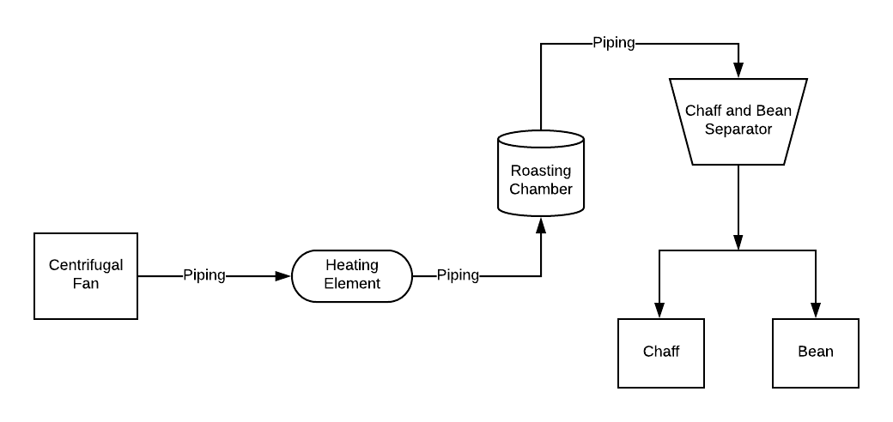

**Figure 3.3a - Heating Element and System Schematic**

**3.3.1.2 Solid-State Relay**

The functionality of IntelliRoast revolves around its ability to control the temperature of the air entering the roasting chamber with a solid-state relay. Using a signal similar to Pulse Width Modulation (PWM), but slower in frequency, a solid-state relay can turn the heating element on and off. With a custom Proportional-Integral-Derivative (PID) software module, the temperature of the heating element can be controlled to match the roast profile.

The heating element measures 8.8 Ohms and draws 13.6 amps at 120 VAC. Because of the high power consumption of the heating element, a solid-state relay with a high load rating is needed. Two solid-state relays were considered due to these high constraints: the TE SSRDC-200D12 and the Fotek SSR-25DA.

The TE SSRDC-200D12 has a load rating between 0 and 200 VAC and is rated up to 25 amps, well within the operating range of the heating element [22]. The Fotek SSR-25DA allows the operation of up to 380 VAC at 25 amps with only 3 VDC making it the best candidate for the PWM heating element solid-state relay [23]. Fast response time is also a key element in both the PWM control and PID loop, and while the TE has a much faster response time compared to the Fotek, its on and off cycles differ drastically, making its application in a PID loop less practical to implement. Due to the slow response time of heat dissipation, response time less than 1 ms has no effect on the system. The SSR-25DA’s 10 millisecond response time for both on and off triggering, while slower, makes it the better choice for this specific application. Table 3.3b shows the comparison between the Fotek and TE solid-state relays.

**Table 3.3b - Solid-State Relay Comparison Characteristics**

|  |  |  |  |  |  |  |
| --- | --- | --- | --- | --- | --- | --- |
| **Solid-State Relay** | **Price per Unit (USD)** | **Input Rating** | **Voltage Load Rating** | **Amperage Load Rating** | **Response Time (on cycle)** | **Response Time (off cycle)** |
| **Requirements** | < $30 | 5 VDC | 120 VAC | 13.6 A | < 1 s | < 1 s |
| Fotek SSR-25DA [22] | $16.50 | 3-32 VDC | 24-380 VAC | 25 A | 10 ms | 10 ms |
| TE SSRDC-200D12 [23] | $40.06 | 3.5-32 VDC | 0-200 VAC | 25 A | 600 µs | 2.6 ms |

Best Option/Meets Requirements Does Not Meet Requirements

**3.3.2 Centrifugal Fan**

In fluid bed coffee bean roasting, airflow and air pressure are the integral factors for a successful roast. These two characteristics are dictated by the inflow fan located at the beginning of the heat transfer section. The two fan styles considered for providing airflow were axial fans and centrifugal fans. Axial fans are more popular for providing airflow for large volume enclosures such as computer towers or rooms of a building. Centrifugal fans, meanwhile, function well in smaller environments such as small piping. The centrifugal style fan was selected due to its smaller intake surface area, superior static pressure output, and smaller output opening.

Two centrifugal fan styles from the same supplier were considered: the CUI Inc. CBM-979533B-154 (154) and the CUI Inc. CBM-979533B-168 (168). The key distinction between these two candidates is the maximum raw input current. The 168 model has a maximum input power of 48.30 watts, while the 154 model is limited to 22.08 watts [24]. An increase in power means the fan pushes more air through the same sized output. Table 3.3c shows an overview of the fan characteristics.

An inverse relationship between static pressure and obtainable airflow exists for both axial- and centrifugal-style fans. Both the 168 model and the 154 model have a near-linear slope between airflow and static pressure, as shown in Figure 3.3b. Due to the limited inner diameter of the piping used for air and heat transfer, static pressure limits the total available airflow. This static pressure is important to the bean agitation process, as it provides the lifting motion needed to move the beans within the roasting chamber. Because of this, the 168 will be the best overall choice due to its higher maximum static pressure and airflow.

**Table 3.3c - Fan Characteristics**

|  |  |  |  |  |
| --- | --- | --- | --- | --- |
| **Fan S/N** | **Max Power Input (W)** | **Max Air Flow (CFM)** | **Max Static Pressure  (inch H2O)** | **Price** |
| CBM-979533B-154 [24] | 22.08 | 44.2 | 3.39 | $14.45 |
| CBM-979533B-168 [24] | 48.30 | 54.7 | 5.22 | $18.35 |

Best Option/Meets Requirements Does Not Meet Requirements

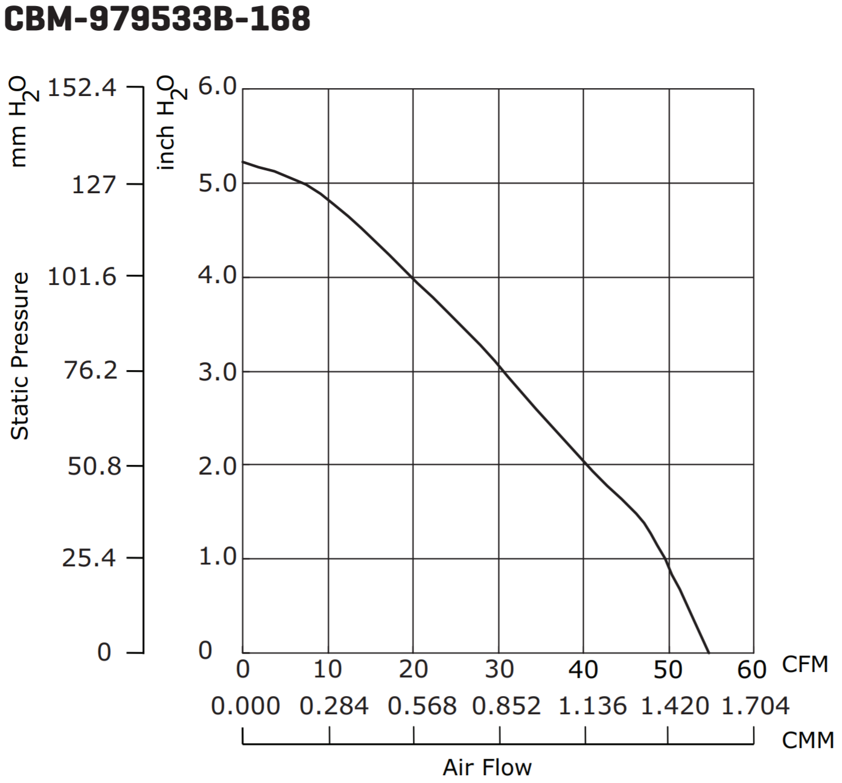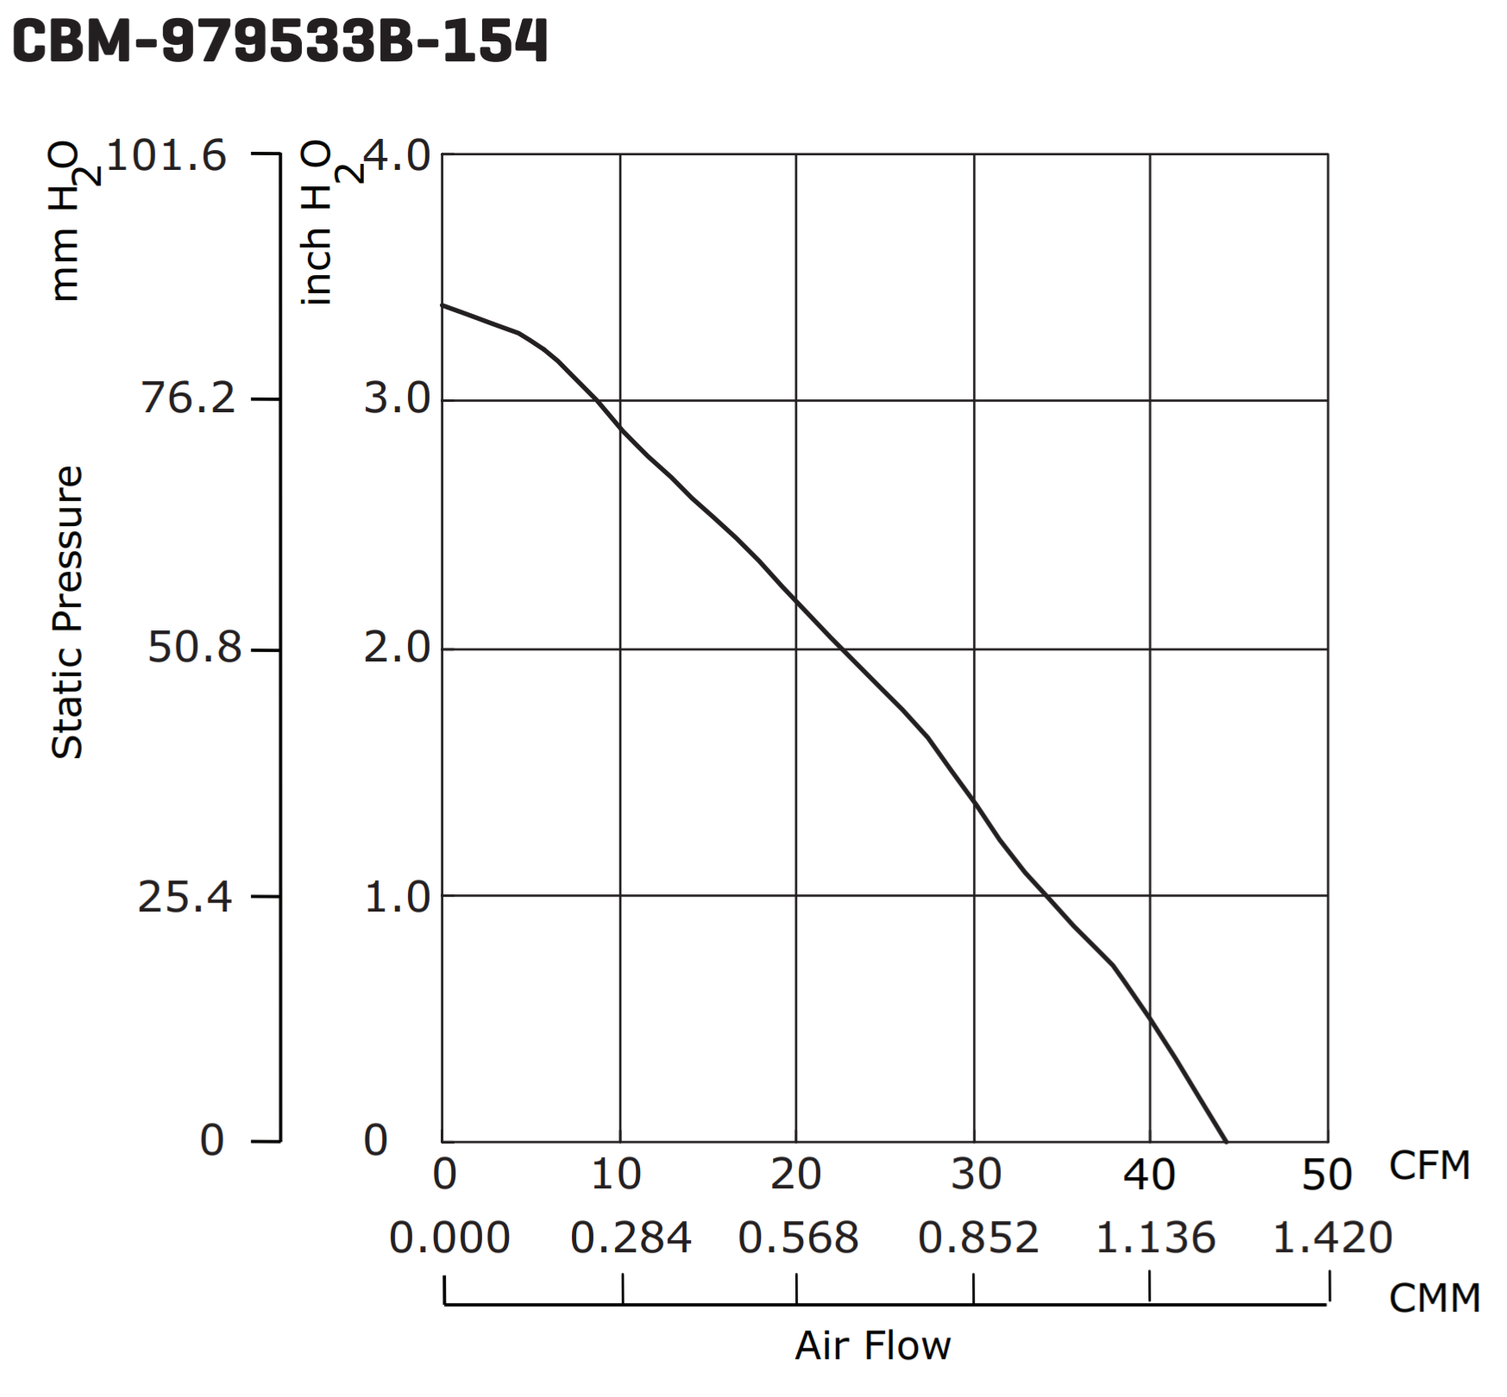

**Figure 3.3b - Comparison of CBM-979533B-168 and CBM-979533B-154 Air Flow to Static Pressure relation diagrams [24]**

The CUI Inc. CBM-979533B-168 centrifugal fan has a maximum airflow output of 54.7 Cubic Feet per Minute (CFM) or 1.549 Cubic Meter per Minute (CMM) [24] with an exhaust size of 30 millimeters by 40 millimeters. The piping selected for air transfer has an inner diameter of 35 millimeters. The airflow efficiency (3) is obtained by taking the area of both openings and dividing the area of the pipe (A2) (2) by the area of the centrifugal fan’s exhaust area (A1) (1).

(1) (2)

(3)

The airflow efficiency is then multiplied by the maximum output of the centrifugal fan (U) to calculate the maximum achievable air flow (Umax) through the piping (4).

$U_{max}= U*0.807 = 44.14 CFM = 1.245 CMM$ (4)

Using the graph correlating air flow to static pressure (Figure 3.3c), static pressure measured in millimeters of water (mmH2O) can be obtained [24].

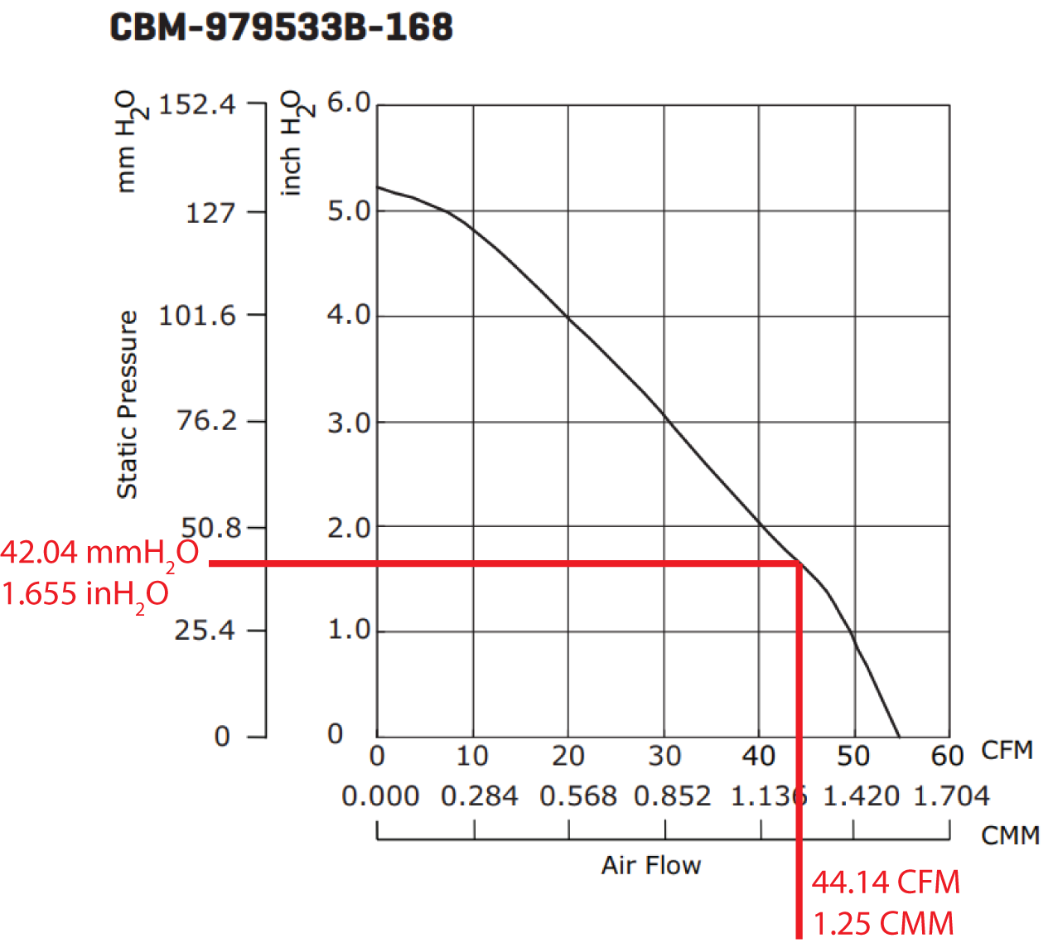

**Figure 3.3c - Airflow to static pressure relation**

Total thrust force (F) is calculated from the mass flow rate (ṁ) times velocity (V) (5)

$F = ṁ * V \frac{kg*m}{min^{2}}$ (5)

Where:

$ṁ = U_{max} * ρ \frac{kg}{min}$ (6) $V = \frac{U_{max}}{A_{2}}\frac{m}{min}$ 
 (7)

The density of air (ρ) is assumed at 25 ºC

$ρ = 1.225 \frac{kg}{m^{3}}$ (8)

Calculating area of the piping in meters ($9.62*10^{-4}$ m), we can combine Equations 5 through 8 to obtain

$F = {(U}_{max} * ρ) * (\frac{CMM}{A_{2}}) \frac{kg*m}{min^{2}}$ (9)

Substituting in values:

$F = (1.245 *1.225) * (\frac{1.245}{9.62*10^{-4}}) = 1973.78 \frac{kg*m}{min^{2}}$

Converting F to Newtons (FN):

(10)

$F_{N} = \frac{1973.62}{3600} = 0.548 N = 548 mN$

Additionally, to agitate the beans, the maximum airflow the fan can produce while also allowing the air to be heated to 300 °C is calculated. If the air flows over the heating element too quickly, the fan will cool the heating element below the target temperature. Conversely, if the air moves too slowly, it will not agitate the beans and provide an even roast. Equation (11) finds the heat transfer rate where Qdot is the amount of heat transferred per second over an area, hc is the heat transfer coefficient, Ac is the cross-sectional area of the piping, Tfluid is the temperature of the air, and Tcoil is the temperature of the heating element.

$Q_{dot}=h_{c}*A_{c}*(T_{fluid}-T_{coil})$ (11)

where $h_{c}$ is calculated using the thermal conductivity of air (k), Nusselt’s number (Nu), and the diameter of the steel piping (D) as shown in Equation (12). Nusselt’s number, calculated in Equation (13) is an important aspect of the calculation since it represents the ratio of convection to conduction in heat transfer and is found using Reynold’s number (Re). Reynold’s number is found using the velocity of air (U) found to be between 10 and 23 meters per second, the diameter of the black iron piping (D) found to be 0.035306 meters, and the volume of air (V) at 25℃ found to be 1.562x10-5 meters per second in Equation (14).

$h_{c}=(k*Nu)/D$ (12)

$Nu =0.927*(Re^{0.5})$ (13)

$Re =(U*D)/V$ (14)

The value of Qdot is then used in Equation (15) where mass flow rate ma represents the air flow in cubic feet per minute over the heating element, h1 and h2 are enthalpy values of 295.15 and 653.47 respectively. Calculating ma is done to find the flow rate necessary to heat the air to the desired roasting temperature. From these values, it was clear the rating given by the heating element might not be satisfactory to heat. Changing the diameter of the steel piping allows for a larger volume of air to flow over the heating element and therefore, heat the air to 300℃.

$Q_{dot}=m_{a}*(h_{2}-h_{1})$ (15)

Another reason why the airflow through the fan is critical is because of the fluidization of the coffee beans. The fluidization velocity is the point where solid particles act like a fluid by rising and falling due to the drag provided by the air. This value can be determined by balancing the downward forces with the upward forces in the system. Downward forces are equal to the weight of the total fluid bed minus the buoyancy forces. Upward forces are equal to the drag provided from the air. Buoyancy forces were negligible because of the size of the solid particles - in this case, coffee beans.

The size of the coffee bean is critical to how much fluidization velocity is required. Therefore, the volume of a single bean is calculated in Equation (16), where h is the height of the coffee bean at 0.36 inches, w is the width of the bean at 0.295 inches, and d is the depth of the bean at 0.185 inches. A bean adjustment factor (BA) of 0.8 is applied to account for the unique geometry of coffee beans, as not all beans are the same volume.

$V_{B}=h*w*d*BA$ (16)

$V_{B}= 0.36*0.295*0.185*0.8=0.0157 in^{3}$

The void fraction ε represents the fraction of total volume that is occupied by the gas phase, defined in Equation (187. In this case, the void fraction represents how much air space is available in a unit volume of material. VB represents the 100% Volume of Beans inside the chamber and VP represents the volume of the particles, taken by multiplying the value from Equation (16) by 100 to represent the actual volume of coffee beans inside the roasting chamber.

$ε=(V_{B}-V_{P})/V_{B}$ (17)

$ε =(24.718 - 1.57)/24.718 = 0.936$

This value can be placed into Ergun’s equation (18) to calculate the drag on a coffee bean provided from the air,

$g(ρ_{S}-ρ)=\frac{1.75ρv^{2}}{dε^{3}}+\frac{150μ(1-ε)v}{d^{2}ε^{3}}$ (18)

where μ is the viscosity of air, ρ is the density of air, d is the diameter of the coffee bean, and v is the fluid velocity. From these values, an air velocity of 8.91 ft/s2 was obtained. To ensure this velocity is obtainable through the fan, the maximum mass flow rate was taken and choked flow, a condition where a flowing fluid at a given pressure and temperature passes through a constriction like a nozzle, was assumed. This was converted to a volumetric flow rate to a velocity, which ensures the required fluidization velocity is met.

**3.3.3 Hardware Control System**

The hardware portion of the control system uses multiple parts to roast the coffee. The microcontroller unit (MCU) is a STMicro STM32F207ZG [25]. For the BLE subsystem, the STMicro SPBTLE-RF board [26] provides an interface accessible over SPI. The temperatures of the various points in the heating system will be read using k-type thermocouples [27]. These will be paired with a Maxim Integrated MAX31855 thermocouple-to-digital chip [28]. The heating element will be controlled using a Fotek SSR-DA25, as discussed in Section 3.3.1.3.

**3.3.3.1 Microcontroller**

The STMicro STM32F207 MCU was chosen for several reasons. STMicro offers a competitively priced development board, the Nucleo-F207ZG, at $25 through popular distributors, while the leading competitive product, the Arduino Uno R3, costs $22. The STMicro MCU bests the Arduino Uno in every category except price, from clock speed to amount of available flash memory on-chip. Currently, IntelliRoast requires 2 separate hardware timers to run the PWM signals for the fan controller and heating element relay. An additional timer will enable the ability to add sound effects to the device to signal start and stop of roasts. The chip also needs to support a real-time operating system as the number of task and timing of those tasks would be complicated to run in a single loop. Multiple SPI busses are required for the 2 thermocouple amplifiers and bluetooth module. As seen in Table 3.3d, the STM32F207 meets all of IntelliRoast’s requirements and has enough headroom to allow for additional features after IntelliRoast hits the market. While the unit price of the MCU itself is more than the Atmega 328P, STMicro’s libraries allow for further development on this chip. A lower cost STM32Fx chip can be swapped in and still work without incurring a development penalty down the road. Additionally, the STM32Fx line of chips is based on ARM’s Cortex-M3 architecture. This architecture is used by several different embedded-systems manufacturers and allows for other development tools and code to be used with the STM32Fx chips.

**Table 3.3d - MCU Features and Specifications**

|  |  |  |  |  |  |
| --- | --- | --- | --- | --- | --- |
| **Development Board** | **Clock Speed** | **SPIs** | **Timers** | **GPIO Pins** | **Price** |
| STMicro Nucleo-F207 | 120 MHz | 3 | 12x16bit | 140 | $24.47 |
| Arduino Uno | 20 MHz | 1 | 1x16bit | 23 | $23.38 |

Best Option/Meets Requirements Does Not Meet Requirements

**3.3.3.2 Temperature Sensors**

IntelliRoast’s heating element reaches temperatures of 450 °C under operation, so the sensor must be able to accurately read 450 °C at a minimum. To ensure the sensors accurately measure the roasting temperature, the sensors must have an accuracy of around 5 °C. Fine temperature resolution is important because of the varying temperatures in a roast profile.

K-type thermocouples are the most common thermocouples used in industry because of their inexpensive construction and high (482 °C) heat rating. The thermocouples were originally mounted to the inside of the chamber. As part of a safety analysis to ensure the roaster can be operated in-home safely, the thermocouples were moved from inside the roasting chamber. These were placed before and after the roasting chamber instead. No effect was seen as a result of the thermocouple movements.

These thermocouples must be paired with a thermocouple amplifier as the change in voltage across the thermocouple leads can be as small as 10 µV/°C. This is too small for the analog-to-digital converter (ADC) on the microcontroller to be read accurately. Therefore, a voltage amplifier allows the small change in voltage to become a usable change in voltage. The Maxim Integrated MAX31855 combines an amplifier with calibration logic and an ADC in a single chip. It is a 14-bit ADC with a 0.25 °C resolution and a variance of 2 °C within the range of -200 °C to 700 °C.

**3.3.3.3 Fan Controller**

The fan control is integral to a fluid bed coffee roaster like IntelliRoast. The speed of the fan determines whether the heating element can roast coffee, whether the beans are agitated, and whether the beans can be ejected from the roasting chamber at the end of the roast. The fan can be accurately controlled using a microcontroller via a pulse width modulation (PWM) signal, which works by rapidly toggling a pin on and off at a high frequency. The ratio of time the pin is on versus off over a given period results in an average voltage. This type of signal can be applied to devices such as fans to simulate varying the voltage. Since the fan draws too much power to be connected directly to the microcontroller pin, a power MOSFET, such as the Vishay Siliconix SUP85N10-10, is placed between the fan and the microcontroller [29].

**3.3.3.4 Hardware User Interface**

The user interface on IntelliRoast itself is simple and easy to use. It includes a pair of buttons signaling “Power On/Off” and “Start Roast” respectively. These are paired with LEDs which provides the user with feedback on the roaster’s current state. This includes signaling that the roaster has been brought out of standby, the roaster is scanning for the smartphone app, and the roaster has begun or finished roasting. Beyond this, the companion smartphone application provides the rest of the user interface for the roaster. The buttons tie to an input pin on the microcontroller, and the LEDs are low-power LEDs that can be driven directly from output pins on the microcontroller.

**3.3.4 Printed Circuit Board**

The main goal of the PCB is to bring all of the individual components and modules off of a breadboard and connect them to the development board more reliably. Additionally, we wanted in integrate a 12 V to 3.3 V regulator to power the development board and modules. The following PCB shown in Figure 3.3d accomplished this. There were issues with the board, but they were all cosmetic (silkscreen improvements for assembly, component spacing). The board electrically performed as intended.

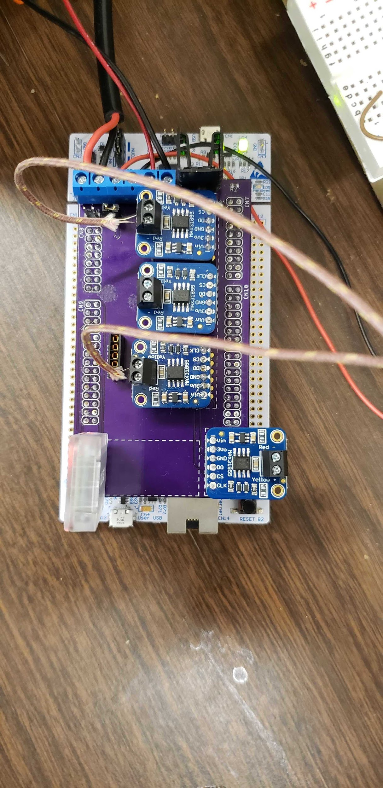

**Figure 3.3d: Bird’s Eye View of PCB installed on Development Board**

## 3.4 Software

The software for IntelliRoast is split into two different components: the controls software and the smartphone app. The controls software oversees the roasting processes, from fan control to heating element control. It also handles communications with the user’s device. The smartphone application provides a high-level view of the roasting process and communicates with the control software.

**3.4.1 Control Systems**

These subsystems include temperature control, fan control, and communications. They interface together to allow the system to follow a simple state diagram outlined in Figure 3.4a.

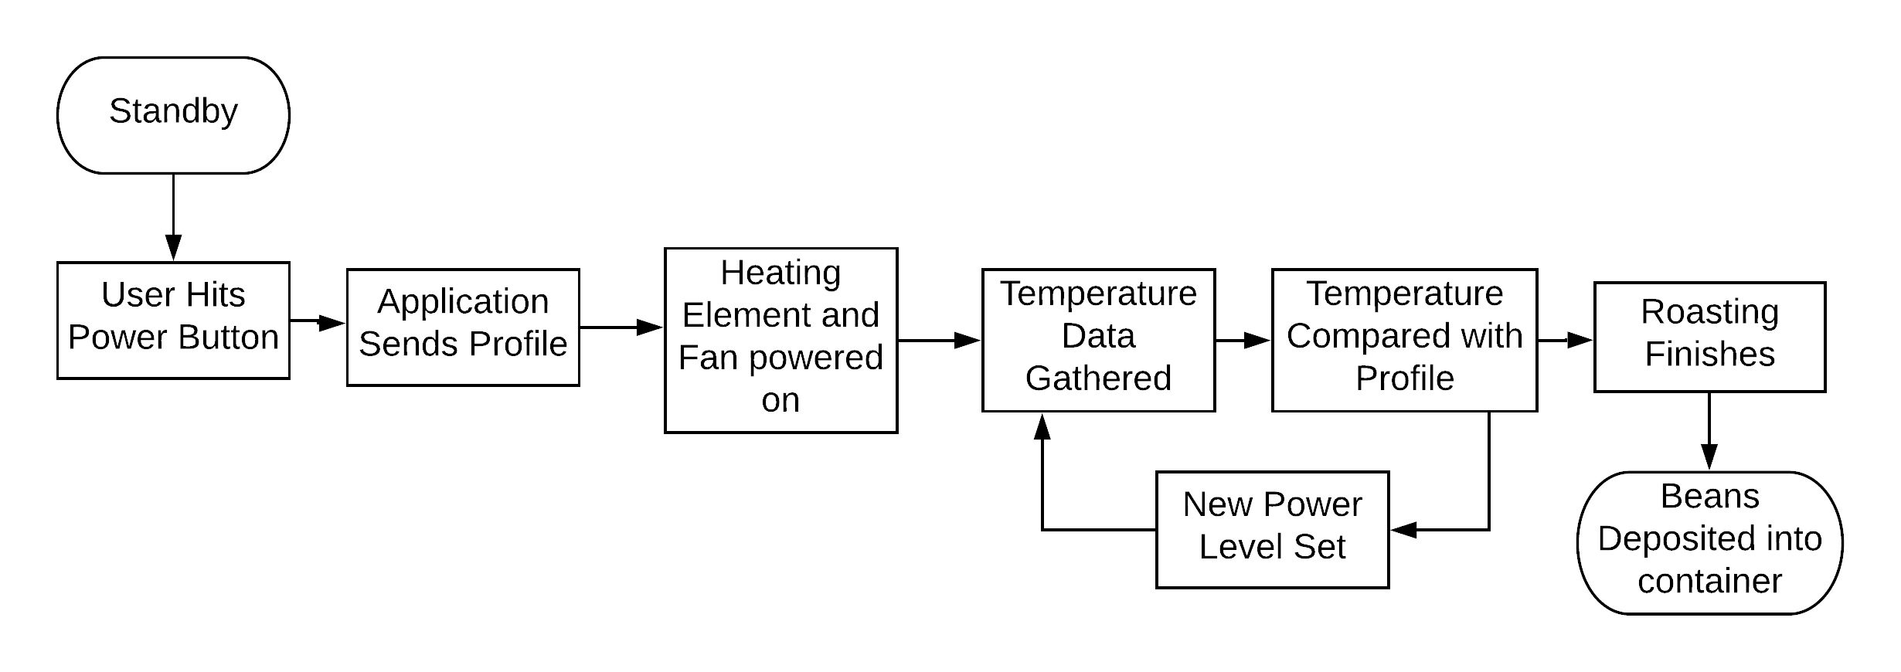

**Figure 3.4a - Control System Flowchart**

**3.4.1.1 Microcontroller**

The control system, as discussed in Section 3.3.3, is built upon a STMicro STM32F2 series chip. The software stack is written in C. STMicro provides several C libraries, including drivers, a hardware abstraction layer (HAL), and middleware. Beyond the easing of development, these libraries allow the code to be portable across STMicro’s STM32 line of processors by targeting the HAL instead of board-specific code.

**3.4.1.2 Temperature Control**

The temperature control system is comprised of three parts: the temperature sensors, fan, and heating element. These components interact with the microcontroller through common interfaces such as timers, interrupts, and SPI buses.

The MAX31855 breakout board allows the microcontroller to read the thermocouples accurately via a SPI bus interface. Each of the thermocouples will be tied to a MAX31855 chip, which will share a single bus. The chips can then be individually addressed by assigning each chip a select line and toggling that line when the temperature at its location is needed. When a chip select line is driven low, the chip provides a 14-bit signed fixed-point number representing the thermocouple temperature. Libraries are currently available for this chip but target the Arduino Uno. These will either be ported to the board directly or used as a reference in the process of writing a library that targets this board.

Using this thermocouple interface, accurate temperature values can be fed into a Proportional Integral Derivative (PID) function. This function determines the new duty cycle needed for the heating element such that the temperature matches the roast profile as time passes. The rate of change of the temperature will be calculated as part of that function. This is returned and sent to the user as a marker for if the roasting process is occurring as expected. The temperature and its rate of change are stored in a buffer until they can be sent to the smartphone application through the communication subsystem, and the new duty cycle is applied to the heating element.

This control loop underwent tuning to add Proportional Integral control. A derivative control portion was added to prevent overshooting of the setpoint marker. This overshoot would affect the consistency of the roast and therefore the flavor of the coffee beans. Fine-tuning the proportional, integral, and derivate portions as well as the integral limits significantly increased the effectiveness of the control loop and the responsiveness of the overall system. The bean temperature is closely set to the setpoint marker., as seen in Figure 4.6b below in Section 4.6.

Fan speed will be controlled by a PWM signal generated by a timer on the MCU. Depending on the phase, a different fan power level is applied. In the roasting phase, the fan is set to the minimum power level needed to allow the beans to properly agitate. If the fan is set too low, the beans in the bottom of the chamber will scorch while the rest will not roast at all. Too high of a power level forces the heating element to ramp up more than necessary and cause the roast to finish too quickly, inhibiting flavor development in the coffee. The cooling phase ramps up the fan to the highest possible power level without causing the beans to be blown out of the roasting chamber before they can cool down. Finally, the ejection phase sets the power level to the absolute maximum to blast the beans up and out of the roasting chamber. These power levels must be determined during prototyping by trial and error.

**3.4.1.3 Communication**

Communication with the application is imperative to provide key additional features to IntelliRoast. Using Bluetooth Low Energy 4.1 (BLE), IntelliRoast transmits and receives roast profiles, commands, and roast data to and from the smartphone app. STMicro provides an STM32 HAL compatible library to interface with the SPBTLE-RF chip over a full duplex SPI bus. STMicro’s libraries handle the setup and use of various Bluetooth profiles (or services) through the SPBTLE-RF chip.

Bluetooth communication is based on the idea of profiles which are specifications for what type of data will be transferred and how. For BLE, most profiles are derived from a single profile, Generic Attribute (GATT). GATT is a general specification for sending and receiving small pieces of data, known as attributes, between devices. IntelliRoast will primarily use this profile to send and receive commands, roast profiles, and roast data to and from the user’s smartphone.

**3.4.2 Smartphone Application**

The smartphone application is responsible for providing the user with extra features and configuration options for IntelliRoast: choosing a roast profile to use, viewing roast progress, and starting and stopping roasting. While not essential for a simple roast, the application provides further customization and control than the hardware alone provides. The user can choose from multiple roast profiles and view more detailed information about each roast profile, such as a temperature plot of the roast, estimated roasting time, and a description of the roast. During a roast, the application shows overall progress and real-time temperatures.

The smartphone interaction is shown in Figure 3.4b.

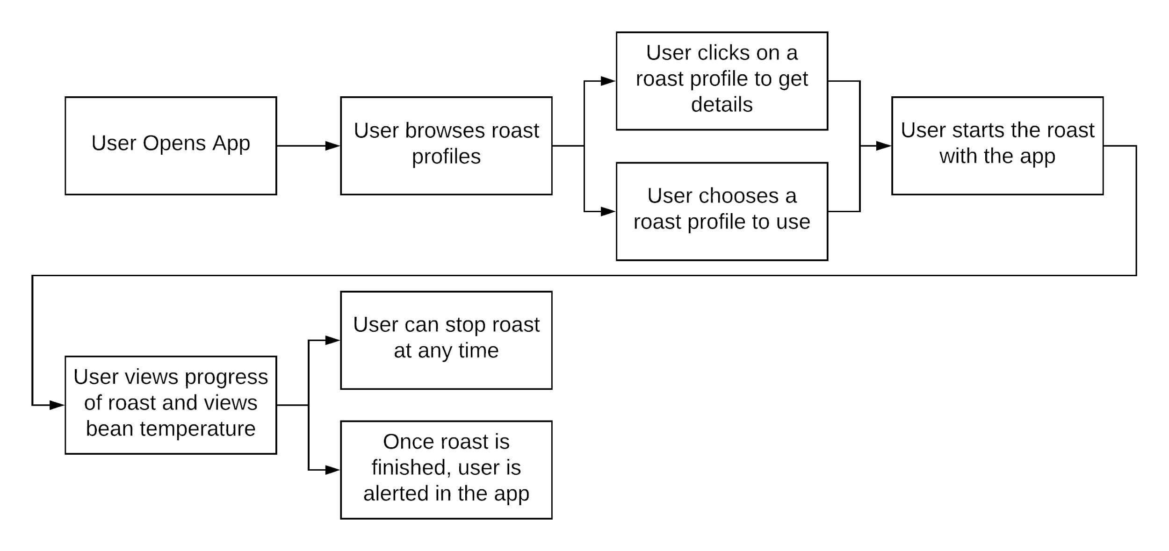

**Figure 3.4b - Smartphone Application User Interaction**

The smartphone application holds a selection of default roast profiles for the user to select, which are stored locally on the user’s device and also on the microcontroller. Roast profiles are defined as 6 data points, where each data point contains a time and a temperature. In software, these time-temperature pairs are stored as a tuple in an array. The smartphone application sends this profile over Bluetooth as a series of twelve 16-bit integers, where each integer represents an alternating time or temperature value. The profile is then stored on the microcontroller in flash memory to be used again without the need of resending the roast. The smartphone application sends the array to the microcontroller, which is used to update the microcontroller’s PID loop.

The application initially supports Android devices and uses Bluetooth LE to connect to IntelliRoast. Android includes Bluetooth LE interfaces in the default libraries, and the application uses those libraries to send and receive data to and from IntelliRoast. Android apps are most commonly written in Java, but they can be written in several different languages. Due to the documentation and online support, IntelliRoast’s smartphone application will be written in Java.

**3.4.3 Use Cases**

The ideal “sunny-day” interaction is as follows: a user plugs in IntelliRoast, pours 120 grams of green coffee beans into the chamber, turns on IntelliRoast, opens their smartphone app, selects a roast profile, and starts the roast. When the roast is completed, the user removes a jar containing their roasted beans, and they need to clean out the chaff from the chaff collection jar before beginning a new roast. The interaction can be seen in Figure 3.4c.

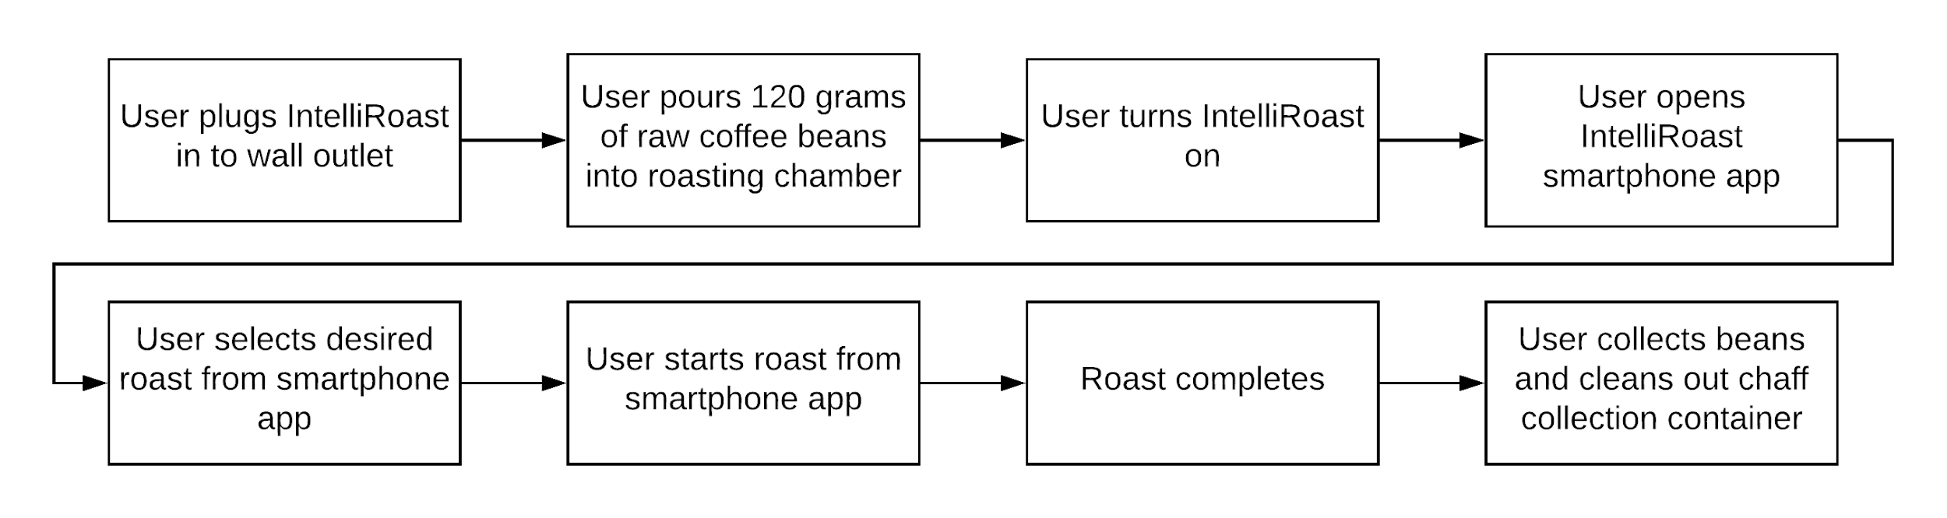

**Figure 3.4c - Sunny-Day User Interaction**

The worst-case “rainy-day” scenario would be if a user could not connect their smartphone to IntelliRoast over Bluetooth. In this case, the user would have to use the default roast profile by pressing the start button on the outside of IntelliRoast. This means the user would not be able to browse roast profiles and choose from multiple types of roasts, but instead they would have to use the roast profile already loaded into the device’s hardware. The default roast profile will be the last used roast or a standard medium roast if no roast has been used yet. A rainy-day interaction can be seen in Figure 3.4d.

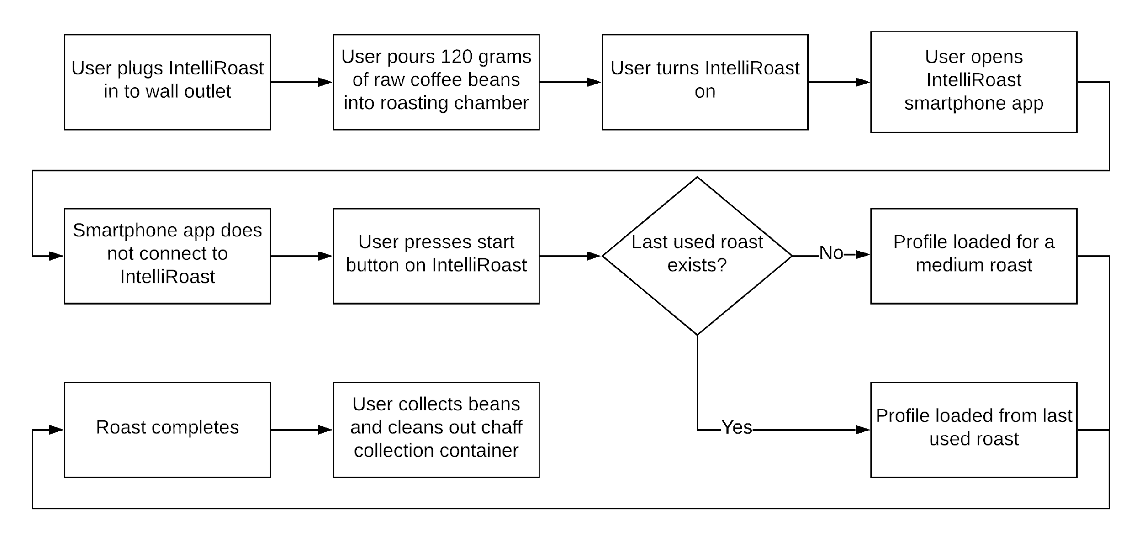

**Figure 3.4d - Rainy-Day User Interaction**

# 4.0 Evaluation

The following section describes the testing of each subsystem IntelliRoast uses for operation. These components were separately tested using lab equipment to verify the component integrity and to ensure the system operates without issues. Table 4a outlines the five technical constraints tested to ensure intended system operation.

**Table 4a - Technical Design Constraints**

|  |  |
| --- | --- |
| **Name** | **Description** |
| Power Draw | IntelliRoast must draw under 15 A at 120 V to comply with NEC standards for kitchen circuit current limits. |
| Roasting Temperature | The heating element must heat the roasting chamber to 300 °C minimum. |
| Surface Temperature | IntelliRoast must comply with ASTM C1055 standards to protect the user from irreversible injuries. The device’s exterior enclosure must not exceed 60 °C. |
| Bean Agitation | IntelliRoast’s fan must lift a maximum of 120 grams of beans to agitate during roasting and eject from the chamber after the roast is finished. |
| Wireless Distance | IntelliRoast must connect to the user’s smartphone from a maximum distance of 3 meters. |

The sections below provide the test data for the subsystems listed in Table 4.0a

## 4.1 Test Certification - Power Draw

IntelliRoast’s power draw testing involved monitoring the power output for the different major electrical components. The elements tested include the centrifugal fan, the microcontroller, and the heating element as seen in Table 4.1a. The total power draw cannot exceed 1800W. From the table, the total power draw is found to be 1685.2, well below the constraint.

**Table 4.1a - Individual Element Power Draw**

|  |  |  |  |
| --- | --- | --- | --- |
| **Element** | **Voltage Draw** | **Current Draw** | **Power Draw** |
| Centrifugal Fan | 12V | 7.025A | 48.3W |
| Microcontroller | 5V | 120mA | 0.6W |
| Heating Element | 120V | 13.64A | 1636W |
|  |  |  | **Total:** 1685.2W < 1800W |

## 4.2 Test Certification - Roasting Temperature

IntelliRoast’s temperature probes must provide consistent, accurate readings to facilitate reliable and repeatable roasts. To test the accuracy, a probe is placed in the roasting chamber, and measurements are taken during the roasting process. The recorded temperature is compared to the recordings from an infrared thermometer. Since the infrared thermometer measures the surface of the beans, it will provide an accurate reading compared to the thermocouple. The MAX31855 thermocouple amplifier provides an internal reference temperature and automatic calibration of the thermocouples. This calibration corrects the non-linear response of the thermocouple. Any recorded errors from the expected values are used to calculate the slope of the error. This can be applied to the reading at any temperature to increase accuracy. Seen in Figure 4.2a, the thermocouples do provide consistent accurate readings during this testing procedure.

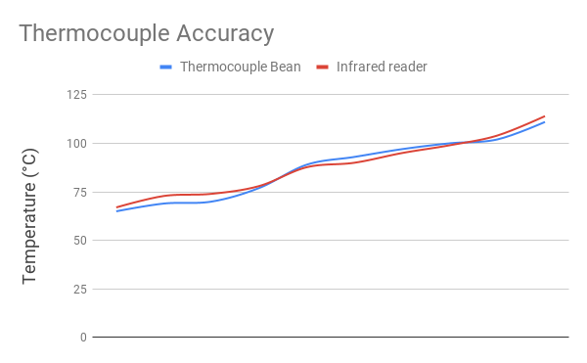

**Figure 4.2a - Thermocouple Accuracy vs. Infrared Thermometer**

The MAX31855 amplifier provides a digital reading of the temperature over an SPI like interface. When the CS line is pulled low and a clock is applied to the CLK line, 32 bits are shifted out onto the data line. The data can then be decoded following the information from the datasheet.

IntelliRoast must provide a maximum roasting temperature of 300℃ in the roasting chamber. This temperature exceeds the maximum temperature of any bean roasting profile. The REPL Heating Element for the HG501A heat gun provides a maximum rated temperature of 371℃. The heating element is tested by using a thermocouple near the heating element in the heating chamber, allowing the air temp to be measured. The thermocouple, wired to the microcontroller, reads the temperature values in degrees Celsius as seen in Figure 4.2c. The duty cycle was varied and the temperature was sustained for 30 minutes to test the reliability of the heating element. During that time the heating element was found to sustain around 500℃ – far exceeding the rated temperature of 371℃.

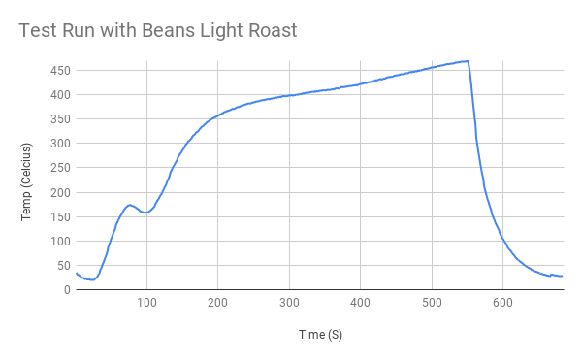

**Figure 4.2c - Temperature Mapping of Thermocouple in Heating Chamber**

To test the roasting temperature, a thermocouple was placed in the roasting chamber, seen in Figure 4.2c, to measure the temperature of the air entering the chamber. Once the temperature of the heating element was adjusted and the thermocouple read 300℃, the temperature was sustained for 30 minutes. This was repeated to ensure the reliability of the roasting chamber.



**Figure 4.2c - Roasting Chamber**

## 4.3 Test Certification - Surface Temperature

IntelliRoast’s surface temperatures must not exceed 60℃ in order to protect the user from burn risks due to normal use. To test the surface temperature, an infrared thermometer is directed at the machine’s faces and interactable components. Electrical tape was used to highlight points to test because the metallic enclosure of the prototype is reflective and does not return accurate values. The test is performed with coffee beans inside during the heating cycle. Temperatures are recorded midway through the roasting process because this point is when the heating element is operating at its highest power. Additionally, since the prototype is made from metal, a visual check is performed with the infrared thermometer to ensure the surface temperature is within requirements.

The faces measured for this test include the left panel, the right panel on the top and bottom areas, the back of the prototype, and the front of the device near the top and bottom. The left panel is measured as a whole because the heating elements are not located on the left side of the machine, so the temperature can be assumed as one value. The right face and the front face are split into two separate areas because of the location of the heating elements. Since the heating elements are located on the bottom near these faces, separate temperature tests must be taken to account for the heat caused by the heating element. The back of the device is measured separately because it is made of a different material than the rest of the outer enclosure. These test results are outlined in Table 4.3a below.

**Table 4.3a - Prototype Enclosure Surface Temperature Test Results**

|  |  |  |
| --- | --- | --- |
| **Area Tested Mid-Roast** | **Temperature Reading Mid-Roast (℃)** | **Pass/Fail** |
| Left | 35.5 | Pass |
| Right (Top) | 38.9 | Pass |
| Right (Bottom) | 53.8 | Pass |
| Back | 38.0 | Pass |
| Front (Top) | 36.2 | Pass |
| Front (Bottom) | 55.5 | Pass |

Interactable components are defined as the roasting chamber area, the chamber removal system, and the chaff collection drawer. These test points are included because users interact with these components during normal use. Care must be taken to ensure no accidental burns are introduced due to the user interacting with the device. The roasting chamber area is included because the roasting chamber is removable by design. The table surface is included because IntelliRoast will sit on a flat countertop surface. This prototype must not burn the countertop surface it sits on. The chamber removal system is tested because the user pulls on the knob at the top of the system to unseal the roasting chamber from the prototype. Finally, the chaff removal drawer is tested because this part is used to remove chaff. These test results are outlined in Table 4.3b below.

**Table 4.3b: Interactable Components Surface Temperature Test Results**

|  |  |  |
| --- | --- | --- |
| **Area Tested** | **Temperature Reading Mid-Roast (℃)** | **Pass/Fail** |
| Roasting Chamber Area | 55.6 | Pass |
| Table Surface | 26.7 | Pass |
| Chamber Removal System/Locking Mechanism | 27.3 | Pass |
| Chaff Removal Drawer | 48.5 | Pass |

Notable temperature results include higher temperature readings near the bottom face of the prototype and the roasting chamber area. These areas are near the heating element and these temperature values include insulation around the heating element to dissipate the heat. Regardless, all critical testing points pass the surface temperature constraint since all critical temperature values were within constraints.

## 4.4 Test Certification - Fan Thrust

The adapter piece shown in Figure 4.4b was designed using SolidWorks and 3D printed to connect these two pieces.

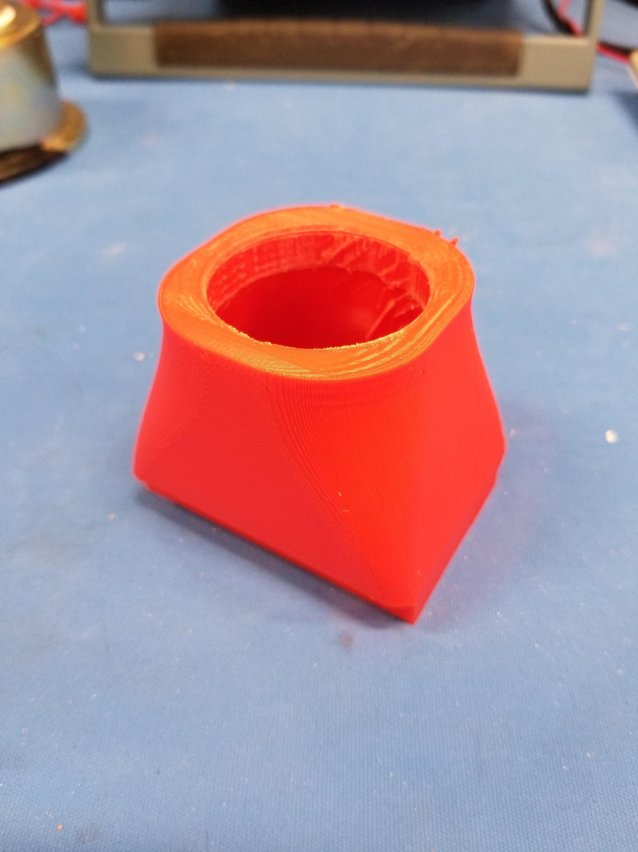

**Figure 4.4b - Centrifugal Fan to 1¼ Inch Piping Adapter**

Shown in Figure 4.4c, an anemometer was placed at the exhaust of the 1¼ inch piping connected to the centrifugal fan to calculate real air flow in meters per second and was recorded at 23.0 meters per second. With the velocity, we can solve for CFM using Equation 7 and obtain UMax = 1.327 CMM, and using Equation 10, FN = 623 mN, 13.7% higher than projected. Connecting the centrifugal fan to the roasting chamber, the fan was able to not only agitate the beans at approximately 60% power capacity but began injecting beans from the roasting chamber at maximum power capacity.

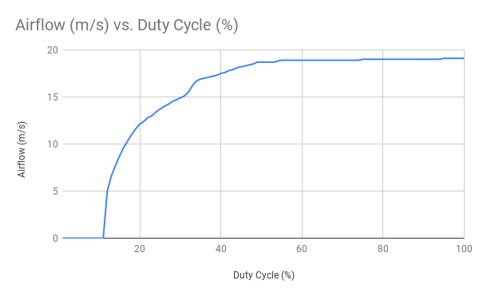

**Figure 4.4c - Real Air Flow Velocity using Anemometer**

Bean agitation was measured by visual inspecting the roasting chamber at different duty cycles of our PWM fan. Shown in Table 4.4a, moderate to absolute agitation is achieved between a duty cycle of 30 and 35 percent up-time. Adequate bean agitation was defined as visible movement between all beans within the roasting chamber. Using Figure 4.4c, these duty cycles correspond to 15 and 16.5 m/s respectively.

**Table 4.4a - Bean Agitation Compared to Fan Duty Cycle**

|  |  |
| --- | --- |
| **Duty Cycle (%)** | **Bean Agitation** |
| 15 | No |
| 25 | Minor |
| 30 | Moderate |
| 35 | Yes |

## 4.5 Test Certification - Wireless Distance

IntelliRoast uses Bluetooth LE (BLE) to connect to the companion smartphone app, and the app needs to be able to connect from 3 meters away. This distance allows the user to connect to IntelliRoast from anywhere in their kitchen. A standard kitchen is 100 square feet, and as seen in Figure 4.5a, a user can be 3 meters away from IntelliRoast and still be in the same kitchen as the device. Two different types of tests were run: one that measured the signal strength at 3 meters away and one that measured maximum wireless distance before disconnecting.

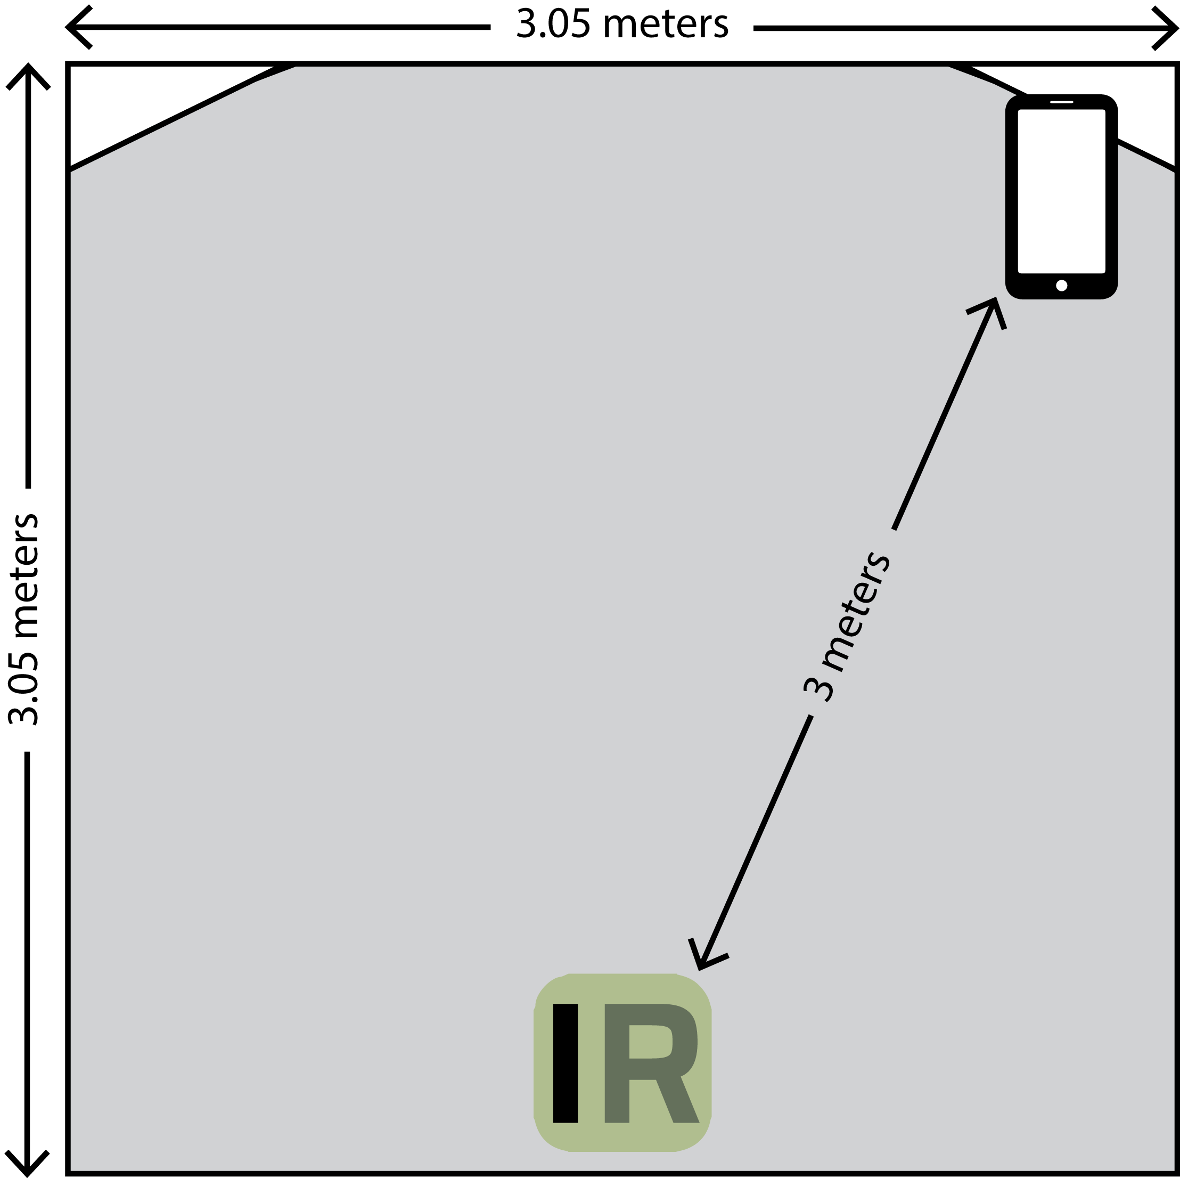

**Figure 4.5a - Smartphone Distance from IntelliRoast in Standard Kitchen**

An app called Bluetooth Signal Meter made by NeoFrontier Technologies can measure the BLE signal strength from IntelliRoast [30]. The signal strength is measured in Received Signal Strength Indicator (RSSI) as a value in decibel-milliwatts (dBm) with a range from 0 dBm to -120 dBm, with values closer to 0 dBm representing stronger signals [31]. An RSSI less than -80 dBm is considered unacceptable, and an RSSI greater than -70 dBm is considered ideal. A series of real-world tests can be run by connecting to IntelliRoast with the smartphone app and tracking how far away you can get from the device before the connection drops. Figure 4.5b shows the RSSIs collected from different distances away from IntelliRoast. At a range of 3 meters or less, the RSSI remains greater than -70 dBm, and the RSSI is greater than -80 dBm up until 9 meters away.

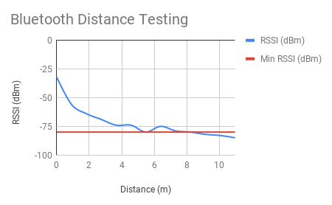

**Figure 4.5b - RSSI (dBm) vs. Distance**

## 4.6 Test Certification - Full System Test

A full system test was performed once all the subsystems were integrated together. The integration of the fan and heating element is vital to the system and was tested separately prior to being fulling integrated. Once the correct operation of the system was verified, 120 grams of unroasted coffee beans were added to the roasting chamber. From there, full bean agitation, fan speed, and heating element temperature were verified.

The fan connects to black iron piping and blows air into piping, across a heating element, through more piping, and then into the roasting chamber. There is additional piping exiting the roasting chamber into the chaff collector. Figure 4.6a shows a side view of the entire system connected together. The heating element section drops the overall max air pressure down from 1.327 CMM to 1.055 CMM, which still provides enough bean agitation for the roast.

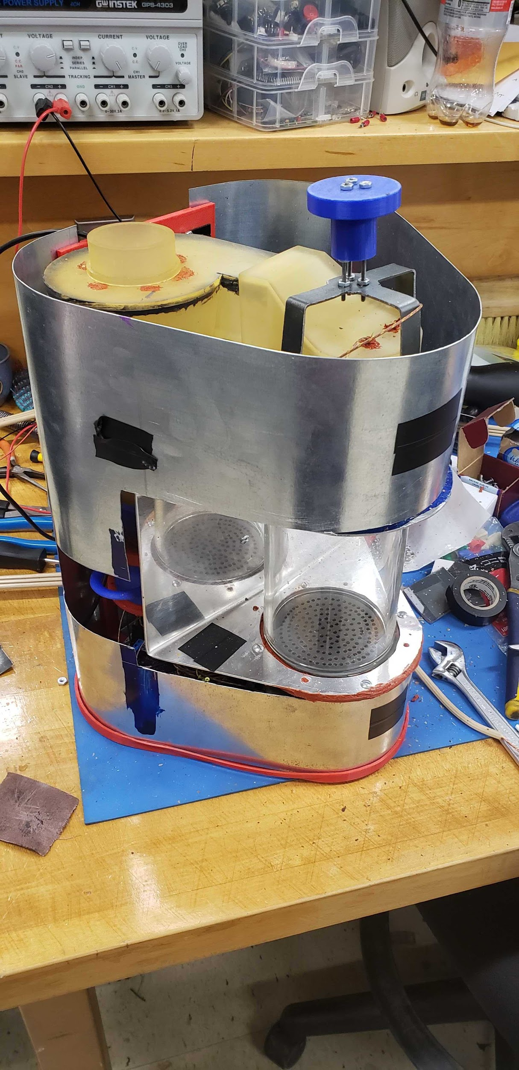

**Figure 4.6a - Full System**

IntelliRoast is specifically made to handle 120 grams of beans. If a user puts in too many beans, for example, 180 grams, the roast still functions but will be uneven. If too few are added, the roast is not affected negatively. The roast will continue as programmed and the beans will still be ejected. If a number of beans are added to the chamber such that the beans cannot be ejected, manual intervention will be required. The roast will abort if the beans overheat and cooling does not work, and the hot beans become a fire hazard.

In the case of power disconnecting from IntelliRoast in the middle of a roast, the user needs a way to retrieve the half-roasted beans from the chamber without running an entire roast again. There is an option from the app to eject leftover beans and debris which turns the fan on full blast and clears out the roasting chamber.

To test the full system, a fully automated roast was performed. The roast was monitored and compared to one performed by a local coffee roaster with the same beans. The roast results can be seen in Figure 4.6b, with the local roaster’s results in Fahrenheit seen in Figure 4.6c. Two key components to a good roast are the final temperature and the rate of rise. The final temperature for a roast specifies what kind of roast is being performed, whether it be light, medium, or dark. The observed roast was a light roast with a final temperature of 200 ℃. As seen, the roast hit 200 ℃ and then switched to cooling the beans. The second component to look for in a roast is a consistent rate of rise. This is where Intelliroast excelled compared to the manual roast perform by the local coffee roaster. The latter half of the roast should have a steady rate of rise. The manual roaster performed well with only minor rises and falls in the rate of rise. IntelliRoast, having a fully automated control system, held a steady rate of rise during the latter half of the roast.

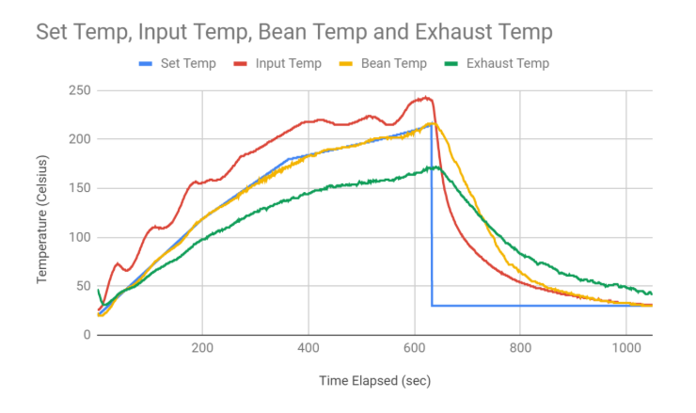

**Figure 4.6b - Roast Results Performed using IntelliRoast**

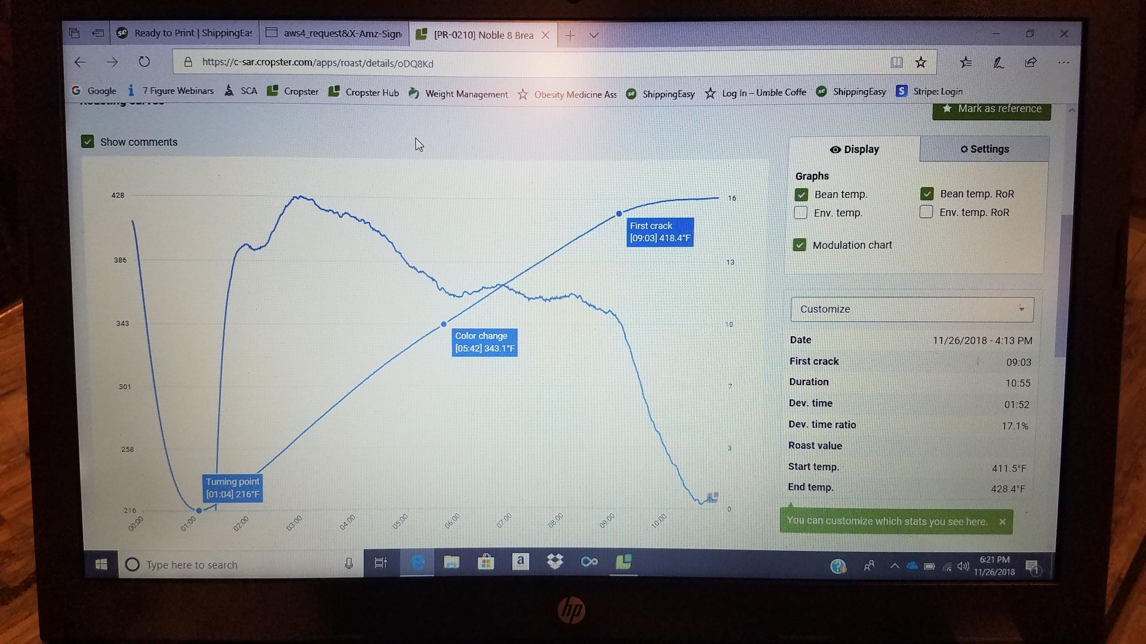

**Figure 4.6c - Roast Results Performed by Local Roaster**

## 

## 5.0 Future Work

IntelliRoast currently has an algorithm in place to determine spikes in coffee-roasting audio. In the near future, IntelliRoast plans to develop a method of capturing this analysis in real-time. Currently, the algorithm interprets the audio file and can determine when changes in bean agitation is recorded, as shown in Figure 5 below. The sample audio file has bean agitation occuring in the first half of the audio file, and none occuring in the second half of the audio file. The algorithm sets a percentage of audio values to isolate, as these correlate to values above the programmed threshold.

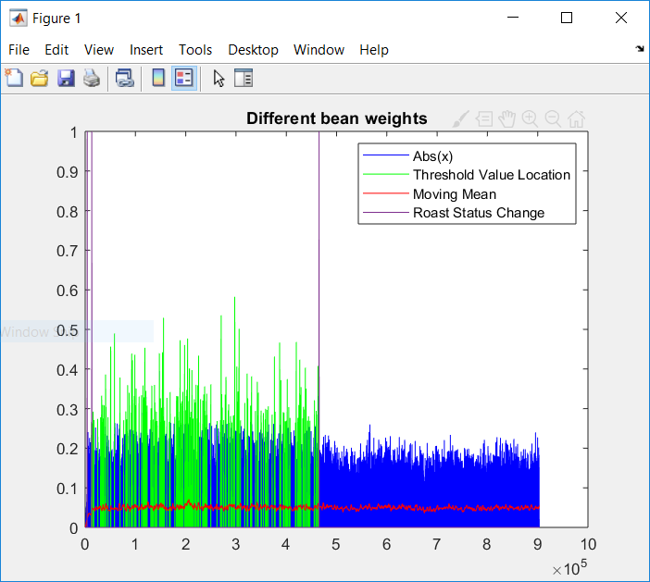

**Figure 5: Bean Agitation Roast Status Image**

As seen above, a valid algorithm was developed to determine changes in bean agitation status. Once the threshold is not reached after a sufficient length of time, the algorithm can determine when bean agitation is not occurring further. The audio signal looks through the sound files to determine spikes in the audio. These can correlate to spikes in the frequency relating to first and second cracks. A spot for a microphone is allocated on the PCB for future development.

IntelliRoast’s roast profiles will continue to be improved as more testing for taste and quality takes place. The local coffee roaster, Umble Coffee, and their resources will be vital to this next step as more knowledge about coffee roasting and its nuances is gained. This partnership will continue despite plans to base the company out of Huntsville, Alabama.

With a viable prototype, IntelliRoast has begun the initial steps of forming a company to become successful as a coffee roaster company. Chaise Farrar, Noah Siano, and Rebecca Siciliano plan on pursuing this as a business venture on top of their careers. IntelliRoast has already started the VentureCatalyst program offered through Mississippi State’s E-Center and is already in the second step of their four-step process. IntelliRoast has already began attending coffee roasting trade shows like Grind City Coffee Expo and others. Trade shows like these help push IntelliRoast’s exposure and push further into the market.

## 6.0 Acknowledgements

**Jordan Strebeck**

Special thanks to Jordan for joining the team for Spring 2019 and his work concerning calculations behind fluidization, heat transfer, material selection, safety analysis, PID control optimization, roast profile data analysis, and offering input on the mechanical design. The prototype would not be in its current state without his valuable input

**West Gorman**

Special thanks to West for his assistance with part fabrication for our Design 2 prototype.

**Dr. Masoud Karimi**

Special thanks to Dr. Karimi for advising the team on power control and our heating element throughout development.

**Kopis Mobile**

Special thanks to Kopis Mobile for their continued sponsorship and gracious advice given throughout the development and testing phase of IntelliRoast.

**Umble Coffee**

Special thanks to Umble Coffee, the local coffee roaster, for their support and continued advice as IntelliRoast improves the roasting profiles necessary for great-tasting coffee.

# 7.0 References

[1] W. Ukers, *All about Coffee*. New York City, NY: Tea and Coffee Trade Journal Company, 1922.

[2] S. Checchia, “Coffee Roaster Ensures Freshness From Very First Drop,” *Chicago Tribune*, 17-Apr-1986.

[3] “Best Home Coffee Roasters 2018.” *Home Grounds* [Online]. Available: https://www.homegrounds.co/best-home-coffee-roasters/

[4] “IKAWA AT HOME.” *IKAWA* [Online]. Available: https://www.ikawacoffee.com/at-home/

[5] K. Davids, *Home Coffee Roasting: Romance and Revival (revised ed.).* St. Martin's Griffin, 2003, pp. 109

[6] L. Wallender. (2018). *Basics You Must Know About Kitchen Electrical Code*. [online] The Spruce. Available at: https://www.thespruce.com/kitchen-electrical-code-basics-1821527 [Accessed 17 Sep. 2018].

[7] ASTM. *ASTM C1055 - 03(2014) Standard Guide for Heated System Surface Conditions that Produce Contact Burn Injuries*. [online] Astm.org. Available at: https://www.astm.org/Standards/C1055.htm [Accessed 17 Sep. 2018].

[8] B. Lokker, T. Allison, Benz, Christine, S. Mutabuzi, Carlos, Graham, Bartek, Mark, Joel, Sravan, Robert, J. Miguel, Pam, Olufemi, David, Claire, National Online Coffee Distributor, Coffee Owl, Gayo Coffee, and Juan Miguel @Light Roast Coffee, “Coffee Roasts from Light to Dark,” *Coffee Crossroads*, 04-Jan-2017. [Online]. Available: https://www.coffeecrossroads.com/coffee-101/coffee-roasts-from-light-to-dark. [Accessed: 17 Sep. 2018].

[9] Blackbearcoffee.com, “Coffee Brewing Ratio Chart” [Online]. Available: https://www.blackbearcoffee.com/resources/83. [Accessed: 24 Sep. 2018].

[10] L. Wallender, “Average Kitchen Size? Well, It's Complicated...,” *The Spruce*. [Online]. Available: https://www.thespruce.com/average-kitchen-size-1822119. [Accessed: 24 Sep. 2018].

[11] Nrarep.net. (2018). IP Rating Chart. [online] Available at: http://nrarep.net/IP_Rating_Chart.pdf [Accessed 17 Sep. 2018].

[12] “IKAWA Smart Home Coffee Roaster System,” *IKAWA Coffee*. [Online]. Available: https://www.ikawacoffee.com/product/ikawa-smart-home-coffee-roaster-system/. [Accessed: 17 Sep. 2018].

[13] “Drum vs Fluid Bed Roasters,” *Home*. [Online]. Available: https://www.coffeechemistry.com/quality/roasting/drum-vs-fluid-bed-roasters. [Accessed: 26-Sep-2018].

[14] NeedBrightlife.com, ‘Cyclone Powder Dust Collector Filter for Vacuums White’, 2018. [Online]. Available: https://www.needbrightlife.com/products/cyclone-powder-dust-collector-filter-for-vacuums-white?variant=7986372313136. [Accessed: 25 Sep. 2018].

[15] B.A. Duran III, ‘Galvanized Steel’s Performance in Extreme Temperatures’, 2013. [Online]. Available: https://galvanizeit.org/education-and-resources/resources/technical-faq-dr-galv/galvanized-steels-performance-in-extreme-temperatures. [Accessed: 25 Sep. 2018].

[16] TheGreenAge.co.uk, ‘Thermal conductivity, R-Values and U-Values simplified!’, 2018. [Online]. Available: https://www.thegreenage.co.uk/article/thermal-conductivity-r-values-and-u-values-simplified/. [Accessed: 23 Oct. 2018].

[17] Grainger.com, ‘1" x 48" x 24" Mineral Wool/Foil Backing High Temperature Insulation, Density 8#, Dark Brown’, 2018. [Online]. Available: https://www.grainger.com/product/ROXUL-1-x-48-x-24-Mineral-Wool-Foil-19NE81?gclid=Cj0KCQjwi8fdBRCVARIsAEkDvnKOBQacVu7ui5M3ZSOQ3er3Onaty1FV-ZfzZaWkNGdFFPzwp7LGcKMaAmQdEALw_wcB&s_kwcid=AL!2966!3!70811101703!b!!g!!&ef_id=WhorIAAABRGtr1-i:20181001171643:s. [Accessed: 25 Sep. 2018].

[18] Zoro.com, ‘Fire Barrier Wrap Strip, 12 ft. L’, 2018. [Online]. Available: https://www.zoro.com/sti-fire-barrier-wrap-strip-12-ft-l-sswred2/i/G0664587/feature-product?gclid=Cj0KCQjwuafdBRDmARIsAPpBmVU-zgW__t4FE9dBl-6CCvlSQttZg4QRxlWX8v9yUWIrc_fwbznL6N8aAlCiEALw_wcB&gclsrc=aw.ds. [Accessed: 25 Sep. 2018].

[19] Zoro.com, ‘Fire Barrier Packing Material, 20 ft. L’, 2018. [Online]. Available: https://www.zoro.com/3m-fire-barrier-packing-material-20-ft-l-pm4/i/G3129007/feature-product?gclid=Cj0KCQjwuafdBRDmARIsAPpBmVVJVN1bAS_MODQM0TKVp6fKnF7N954tLDcZmeIHcUV478hHBIyvGUwaAhAQEALw_wcB. [Accessed: 25 Sep. 2018].

[20] BuyInsulationProducts.com, ‘Fiberglass High Temp Tape’, 2018. [Online]. Available: http://www.buyinsulationproductstore.com/fiberglass-high-temp-tape/. [Accessed: 25 Sep. 2018].

[21] *Master Heat Gun: Instruction Manual, Rev. 3*, p. 1-12 [Online]. Available: http://www.masterappliance.com/content/sites/default/files/simple_products/downloads/Master-Heat-Gun-Instruction-Manual-58221.pdf. [Accessed: 25 Sep. 2018].

[22] ”SSRDC-200D12,” Digikey. [Online]. Available: https://www.digikey.com/product-detail/en/te-connectivity-potter-brumfield-relays/SSRDC-200D12/PB2566-ND/8612183. [Accessed: 17-Oct-2018].

[23] *FOTEK*. [Online]. Available: http://www.fotek.com.hk/solid/SSR-1.htm. [Accessed: 17-Oct-2018]

[24] “CUI Inc. CBM-97B DC Blower,” *CUI*, 09-Aug-2017. [Online]. Available: https://www.cui.com/product/resource/cbm-97b.pdf. [Accessed: 17-Oct-2018].

[25] “STM32F207ZG”, *ST.com*, 2018. [Online]. Available: https://www.st.com/content/st_com/en/products/microcontrollers/stm32-32-bit-arm-cortex-mcus/stm32-high-performance-mcus/stm32f2-series/stm32f2x7/stm32f207zg.html [Accessed: 23-Oct-2018].

[26] “Bluetooth Low Energy expansion board based on SPBTLE-RF module for STM32 Nucleo ”, *ST.com*, 2018. [Online]. Available: https://www.st.com/en/ecosystems/x-nucleo-idb05a1.html.[Accessed: 23-Oct-2018].

[27] “Thermocouple Wire Duplex Insulated”, *Digilentinc.com*, 2018. [Online]. Available: https://reference.digilentinc.com/_media/reference/pmod/pmodtc1/pmodtc1_thermocouplewire.pdf. [Accessed: 23-Oct-2018].

[28] "MAX31855 Cold-Junction Compensated Thermocouple-to-Digital Converter - Maxim", *Maximintegrated.com*, 2018. [Online]. Available: https://www.maximintegrated.com/en/products/sensors/MAX31855.html. [Accessed: 23- Oct- 2018].

[29] “SUB85N10-10 product information”, *Vishay.com*, 2018. [Online]. Available: http://www.vishay.com/product?docid=71141. [Accessed: 23-Oct-2018]

[30] NeoFrontier Technologies. Bluetooth Signal Meter [Mobile Application Software] Available: https://play.google.com/store/apps/details?id=com.infomultiverse.btmeter. [Accessed: 6-Nov-2018]

[31] “How does RSSI (dBm) relate to signal quality (percent) ?” SpeedGuide.net. [Online] Available: https://www.speedguide.net/faq/how-does-rssi-dbm-relate-to-signal-quality-percent-439. [Accessed: 5-Nov-2018]

# 8.0 Appendix: Product specification

